MGT 3375.003: First Individual Assignment: Marlee Yerkes
Country Risk Analysis: Poland, Namibia, India, Turkey, UAE, Venezuela

Overview
Political and legal environments as well as accessibility to recourse in other countries is important to consider when picking a location to expand our factory. I have assessed corruption scores and rankings, political rights scores, civil liberties scores, economic freedom scores, internet freedom scores, and politically free aggregate scores (also known as global freedom status) for each country to determine which would be the best option for our factory. Some countries (UAE) had outstanding corruption scores, but their political rights scores, civil liberties scores, and global freedom status were the worst out of all the other countries. Other countries (Venezuela) had bad scores across the board, and others had extremely low internet freedom scores (Turkey, and India). That left me with two countries to consider that were even across the board (Poland, and Namibia). In the following text I will give you statistics on each country then explain my interpretation. After, I will recommend the best option for our company to expand our factory, and provide a ranking of the countries from lowest to highest risk, as well as more scores and statistic to support my interpretation.
Poland
Poland has the highest economic freedom score out of all the free or partially free countries (India, Poland, and Namibia). It also has a good global freedom score, as well as a moderate corruption score. It has a political rights score of 34 and civil liberties score of 48. Although Poland doesn’t have the highest economic freedom out of all the other countries, Its global freedom score and civil liberties score is the highest out of all the “free’ countries. This would indicate that political and legal environment in Poland would be easy to assimilate into. Poland’s good corruption score would also indicate that governments would be easy to work with as well. This being said, Poland would be a great option to consider for the location of our new factory.
Namibia
Namibia has the second highest economic freedom score out of all the free or partially free countries (India, Poland, and Namibia). It has a good global freedom score like Poland, as well as a moderate corruption score. It has a political rights score of 31 and civil liberties score of 46 (similar to Poland). All this would indicate that Namibia governments as well as political and legal environment would be fairly easy to penetrate into. Namibia’s scores are just below Poland’s in terms of risk. So, Namibia would be another great option to consider when expanding our factory.
India
India has the third highest economic freedom score out of all the free or partially free countries (India, Poland, and Namibia). India is considered partially free with a corruption score tied to Turkey’s (score 40). It has a slightly lower global freedom score than India and Poland. It also has a political rights score of 34 and civil liberties score of 33 (similar to that of Poland and Namibia). All of India’s scores are decent except for the fact that it is only considered partially free. This would limit our accessibility to recourses and might indicate struggles in legal and political environment. Although India’s scores are significantly better than other countries, I would not consider India because of its partially free status.
Turkey
Even though Turkey has the second highest economic freedom score out of all the “not free” countries (Venezuela, Turkey, and UAE), it has a higher political rights score, civil liberties score, internet freedom score, and economic freedom score than Venezuela and the UAE. It has a slightly more corruption than the UAE, but ties with India with a corruption score of 40. Although Turkey has excellent political rights score, civil liberties score, internet freedom score, and economic freedom score compared to Venezuela and the UAE, the scores are still lower than that of Poland, Namibia, and India. This could indicate trouble with political and legislative matters and could have unintended consequences. Because of this, I would not consider Turkey as a destination for our new factory.
UAE
The UAE has the highest economic freedom score out of all the countries (India, Poland, Venezuela, Turkey, Namibia, UAE), but it has the lowest civil liberties score. It also has the second to lowest political rights and global freedom scores. It has a decent corruption score of 71, which tells us there is not a lot of corruption in the UAE. Although the UAE has excellent economic freedom and corruption scores, it has some of the worst scores for civil liberties, political rights, and global freedom. These scores tell us that we would most likely have trouble accessing resources as well as encounter issues with political and legal environments/governments. Because of these three low scores, I would not recommend the UAE as an option for our new factory.
Venezuela
Venezuela has the lowest corruption score (lots of corruption), economic freedom, political rights, and global freedom scores out of all the countries (India, Poland, Venezuela, Turkey, Namibia, UAE). It had the second lowest civil liberties score. Overall, Venezuela has the worst scores out of all the other countries. This would indicate serious issues with local governments, as well as political and legal environments. We would also encounter the problem of accessibility to resources and even crime. Because of the detrimentally low scores, I would defiantly not consider Venezuela as a location for our new factory.
Best Country to Build the Factory
After carefully consideration and reviewing scores from all countries then comparing them side by side, I have chosen Poland as the best option to consider for out new factory. Poland is the best country to build a factory in because of its high economic freedom score (69.7) out of all the free or partially free countries (India, Poland, and Namibia), good global freedom score (82), moderate corruption score (56), political rights score (34), and civil liberties score (48). These scores implies that Poland would have the lowest risk compared to all the other countries. This means we would have the least issues in legal and political environment as well as local governments. We will not have to be as worried about crime and corruption compared to the other countries, and we will maintain our accessibility to recourses. In conclusion, Poland is the best option, with the least amount of risk, to build our new factory.

Ranking From Lowest to Highest Risk:
1st) Poland
2nd) Namibia
3rd) India
4th) Turkey
5th) UAE
6th) Venezuela
Scores:

 | Corruption | Political Rights | Civil Liberties | Political Free Aggregate Score | Economic Freedom
India | Score:40/100  Rank: 86/180 | Score: 34 | Score: 33 Internet Freedom Status: 49/100 (Partially Free) | Global Freedom Status: 67/100 | Score: 56.5
Venezuela | Score:15/100  Rank: 176/180 | Score: 1 | Score: 13  Internet Freedom Status: 28/100 (Not Free) | Global Freedom Status: 14/100 | Score: 24.7
Poland | Score:56/100  Rank: 45/180 | Score: 34 | Score: 48  Internet Freedom Status: No Data  (Free) | Global Freedom Status: 82/100 | Score: 69.7
Turkey | Score:40/100  Rank: 86/180 | Score: 16 | Score: 16  Internet Freedom Status: 34/100 (Not Free) | Global Freedom Status: 32/100 | Score: 64
Namibia | Score:51/100  Rank:57/180 | Score: 31 | Score: 46  Internet Freedom Status: No Data  (Free) | Global Freedom Status: 77/100 | Score: 62.6
UAE | Score:71/100  Rank: 21/180 | Score: 5 | Score: 12  Internet Freedom Status: 27/100  (Not Free) | Global Freedom Status: 17/100 | Score: 76.9

Exhibit 1: Corruption Scale and Internet Freedom Status

Corruption Scale:
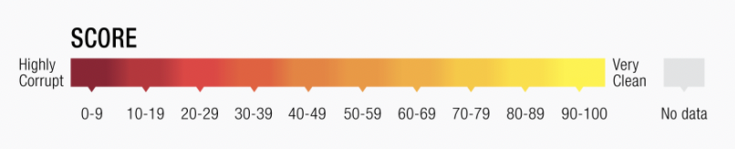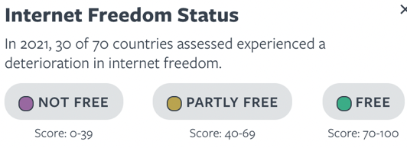
Sources: “Countries and Territories.” Freedom House, https://freedomhouse.org/countries/freedom-world/scores.
Source: “Corruption Perceptions Index 2020 for United Arab Emirates.”
Transparency.org, https://www.transparency.org/en/cpi/2020/index/are.

Exhibit 2: Economic Freedom Scale of Each Country

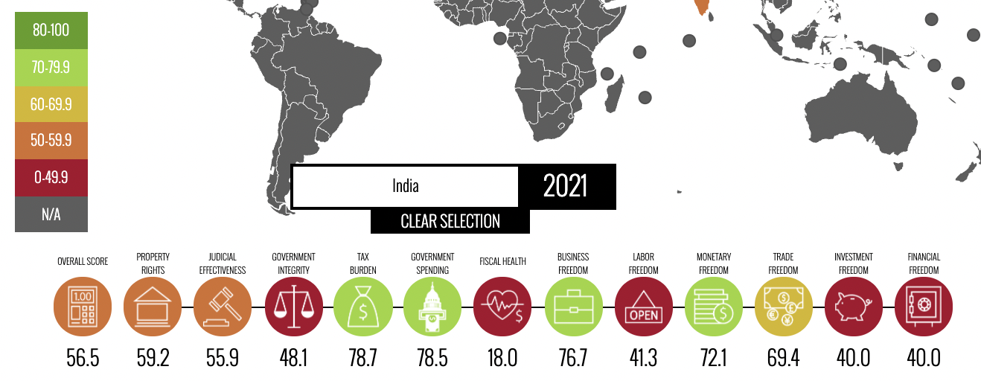
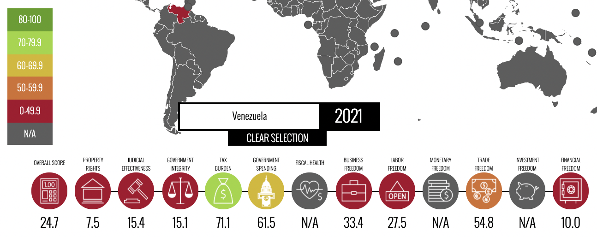
Sources: “2021 Index of Economic Freedom.” Index of Economic Freedom, https://www.heritage.org/index/heatmap.

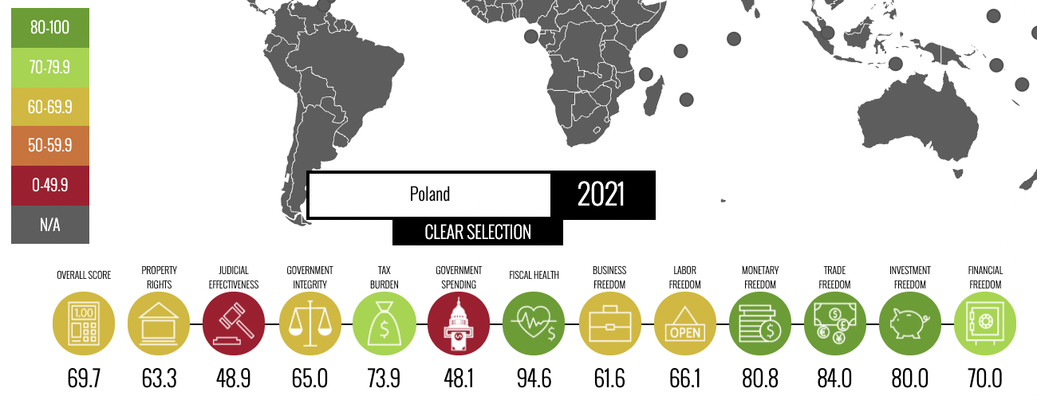
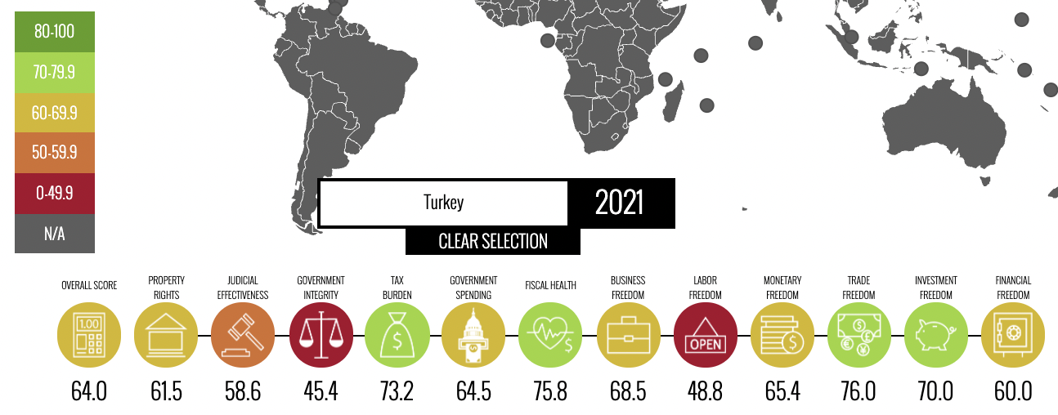
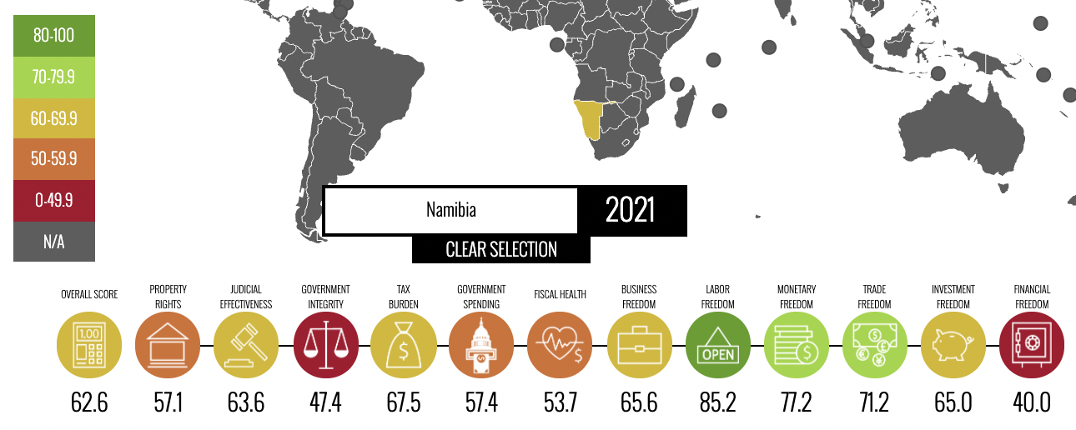
Sources: “2021 Index of Economic Freedom.” Index of Economic Freedom, https://www.heritage.org/index/heatmap.

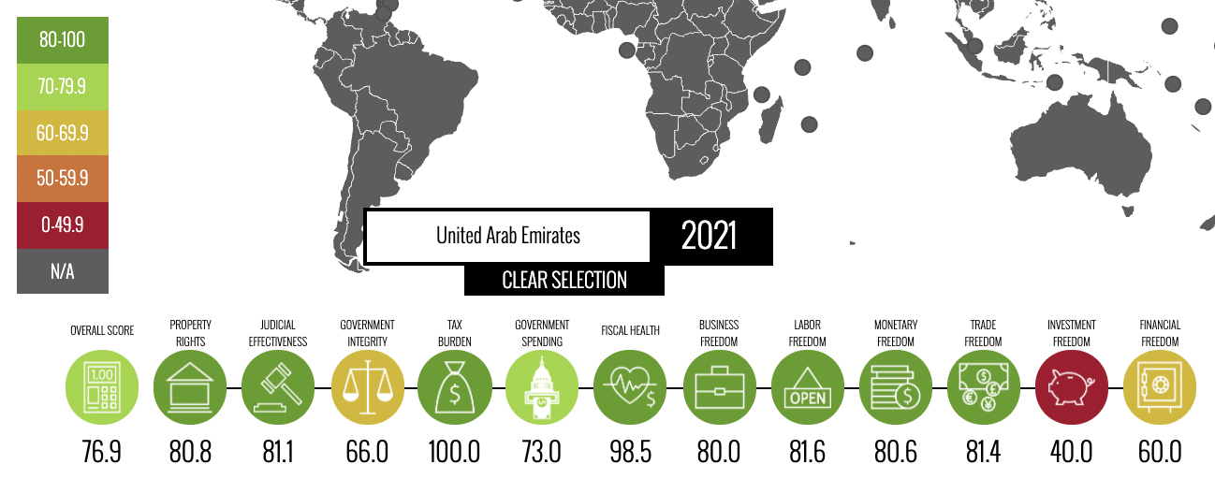

Sources: “2021 Index of Economic Freedom.” Index of Economic Freedom, https://www.heritage.org/index/heatmap.

ENDNOTES

“2021 Index of Economic Freedom.” Index of Economic Freedom, https://www.heritage.org/index/heatmap.
“Corruption Perceptions Index 2020 for United Arab Emirates.” Transparency.org, https://www.transparency.org/en/cpi/2020/index/are.
“Countries and Territories.” Freedom House, https://freedomhouse.org/countries/freedom-world/scores.
“2021 Index of Economic Freedom.” , op. cit.
“Corruption Perceptions Index 2020 for United Arab Emirates.”, op. cit.
“Countries and Territories.”, op cit.
“2021 Index of Economic Freedom.” , op. cit.
“Corruption Perceptions Index 2020 for United Arab Emirates.”, op. cit.
“Countries and Territories.”, op cit.
“2021 Index of Economic Freedom.” , op. cit.
“Countries and Territories.”, op cit.
“Corruption Perceptions Index 2020 for United Arab Emirates.”, op. cit.
“2021 Index of Economic Freedom.” , op. cit.
“Countries and Territories.”, op cit.
“Corruption Perceptions Index 2020 for United Arab Emirates.”, op. cit.
“Corruption Perceptions Index 2020 for United Arab Emirates.”, op. cit.
“2021 Index of Economic Freedom.” , op. cit.
“Countries and Territories.”, op cit.
“2021 Index of Economic Freedom.” , op. cit.
“Corruption Perceptions Index 2020 for United Arab Emirates.”, op. cit.
“Countries and Territories.”, op cit.

