**Internal and External Analysis: General Electric**

Team 4: Marlee Yerkes, Joachim Kroll, Andrew Delong

MGT 4335.260: Strategic Management

Professor Dennis Rose

February 28th, 2022



(PNGSET, 2022)

**Workload Distribution**

**Marlee Yerkes**: Introduction, Abstract, Conclusion, The General Environment, Demographic, Political/Legal, Sociocultural, Economic, Technological, Global, Sustainable Physical, The Competitor Environment, Main Players, Future Competition, SWOT, Industry SWOT, Further Analysis, General Electric SWOT, Further Evaluation, Strategy Recommendations, Capabilities, Technology & Innovation, Customer Service, Global Presence, Differentiation Strategy, Appendix A, Appendix B, Appendix C, Appendix D, Cover Page, References, Editor, Coordinator.

**Joachim**: Sustainable Advantages,Valuable, Rare, Costly to Imitate, Non-Substitutable, The Industry Environment, Threat of New Entrants, Power of Buyer, Intensity of Rivalry, Product Substitutes, Power of Suppliers, Company Structure and Control Systems, Strategy recommendations, Core Competencies, Business-level strategy, resources.

**Drew DeLong**: Value Chain Analysis, History of General Electric, Strategy recommendations, Resources, Existing corporate-level strategy, Resources, Revising & Editing.

**Abstract - Marlee**

General Electric is a company that strives to build a world that works. The company is heavily involved in the machine manufacturing industry, but is also involved in many other industries such as aviation, power, renewable energy, and the digital/technology industry. This industrial company was founded in 1892 by Thomas Edison and has remained a relevant industrial power that continues to set itself apart from others today. General Electric does this with its capabilities of technological innovation, customer service, and global presence. The firm’s business level strategy, corporate level strategy, structure, and control systems allow it to possess sustainable advantages that are valuable, rare, costly to imitate, and non-substitutable. General Electrics also stands out with its unique value chain and supply chain management. The general and industry environment for this company can be very complex, but most risks encountered can be solved if the firm practices continuous learning in regards to industry trends to better position themselves. Competitors of General Electric are currently Boeing, Lockheed Martin, Pratt and Whitney, and Rolls Royce. Although developments from Russia and China might play a role in competition in the future. When it comes to the SWOT analysis, both the industry and company have vast amounts of strengths and opportunities. Of course, there are always some threats and weaknesses involved. To offset this, firms should look for a way to increase profit and sector averages, as well as lower product/service concentration, and capital requirements. General Electric should also take advantage of their wide customer base, diversified geographic presence, and focus on research and development activities to pursue opportunities such as the global renewable energy market, global aircraft market, and create collaborations & partners.

**Introduction - Marlee**

In this paper we will conduct an internal and external analysis of General Electric. This company is entangled in many industries, but for the purpose of this paper, we will give a brief overview of main industries affected, focusing mainly on the aviation sector. We will provide the history of general electric dating back to 1892. Topics such as resources, capabilities, core competencies will also be discussed with technology/innovation, customer service, and global presence being the most relevant capabilities. Sustainable advantages will outline how valuable, rare, costly to imitate, and non-substitutable General Electric is overall. We will also discuss General Electric’s value chain, general environment, industry environment, and competitor environment. A SWOT analysis will be conducted both regarding the industry and company. The final sections of the paper will include information about General Electric’s corporate level strategy, business level strategy, structure, and control systems. The paper will end with a conclusion listing strategy recommendations for General Electric.

**History of General Electric - Drew**

General Electric was founded in 1892 by Thomas Edison as a result of a merger between Thomson-Houston Electric and Edison General Electric with the involvement of J.P. Morgan as the main financier. General Electric started off by creating things such as light bulbs, elevators, motors, and other appliances (Jenkins, R., 2001). General Electric quickly became a successful and profitable company, and in 1896, GE became one of the original 12 companies to be listed on the Dow Jones Industrial Average. Over time, General Electric would branch out into other industries, such as television, water treatment, nuclear reactors, jet engines, etc. and would acquire plenty of other companies, such as the Radio Corporation of America, Telechron, Smiths Aerospace, and many more.

Throughout the history of General Electric, there were many chairmen and CEOs that would switch off every few years, until 1981 when Jack Welch became the CEO and revolutionized the company over the next two decades, increasing their market value from $12 billion in 1981 to $410 billion in 2001. Jack Welch was a very controversial leader in the business world, he didn’t have the most ethical approach as he would frequently make pay cuts to his employees, and drastically reduce the number of employees in the company. In five years under his leadership, the number of employees decreased from 411,000, to 299,000- every year he would fire the lowest performing 10% of managers. However, the numbers don’t lie, and through this aggressive approach, he transformed General Electric into the most successful company at the time. He had streamlined the bureaucracy, and decentralized many operations in GE. Since then, General Electric had sold off many of its redundant businesses and focused on new acquisitions that would be more profitable. The company now operates out of four primary divisions: aviation, healthcare, power, and capital (G. -y. Chen, J. -s. Zhang, 2011) .

**Internal Analysis**

**Resources, Capabilities and Core Competencies**

**Resources - Drew**

General Electric operates out of 82 manufacturing plants in the United States and 142 plants in 34 other countries across the world, with almost 170,000 employees- roughly 40,000 of them are employed in the aviation sector (MarketLine, 2022). Their equipment is top of the line, capable of producing products such as jet engines and helicopters, wind turbines and steam engines, medical imaging machinery such as MRI machines and CT scanners, and much more.

General Electric is one of the most well known companies in the world. It was founded by America’s most prolific inventor in 1892 and has made quite a name for itself since then. The majority of people in America and developed countries have heard of General Electric or at least used one of their products that range from light bulbs and kitchen appliances, to jet engines and medical scanning equipment. Their brand name is well known and highly respected. One of the most innovative companies the world has ever known, GE has an extreme level of knowledge in their industries and continues to prove it.

**Capabilities - Marlee**

The main capabilities of General Electric include: technology & innovation, customer service, and global presence (Mohamed, 2017). General Electric possesses capabilities that have great potential in terms of core competencies, and thus a competitive advantage. If General Electric can sustain these resources and capabilities, they will be able to create strong core competencies, and in turn a sustainable competitive advantage. The following sections will discuss these capabilities in further detail.

**Technology & Innovation - Marlee**

Technology is probably one of the most important aspects of General Electric company growth. That being said, GE has over 37,000 technologists working for them (Mohamed, 2017). This gives GE a competitive advantage when launching advanced technology programs. This also makes room for large scale market potential in new innovative technology. This capability can be seen as valuable for the company and consumers, as it adds value for both of them. Also, this is not common among competitors, so it is rare. We can see that this capability is also inimitable and non-substitutable because of these characteristics (Mohamed, 2017). General Electric’s resources allow them to possess a strong capability: Technology & Innovation. This capability is strongly related to the company's overall growth because now-a-days tech products usually have a short product life span. There are always new products being released in the tech industry. Technology that’s only three years old can be considered outdated due to the continuous stream of new products and technologies in the market. General Electric’s ability to remain innovative in pursuit of new technology development makes this capability one that has a high potential to become a competitive advantage as it highly contributes to company growth and keeps the firm remaining relevant.

**Customer Service - Marlee**

General Electric has increased commitment to customer service by widening their types of services to include technical, financial, training and other forms of customer support, creating a competitive advantage (Mohamed, 2017). The company has also decided to increase financial commitment to marketing. Another method General Electric is using to set its customer service apart from others is by focusing on hiring high talent people to meet the consumer needs. General Electric’s customer service is considered unique as it offers the product in addition to all services needed in regards to the product. General Electric’s customer service can also be considered rare. Excessive customer care and product quality proves that this capability is also inimitable and non-substitutable (Mohamed, 2017). General Electric sets itself apart from others in the customer service arena by offering a wide variety of services, increasing financial commitment to marketing, and by focusing on hiring people who will best meet customer needs. This capability has high potential to become a core competency, and thus a competitive advantage, if General Electric is able to sustain their resources and capabilities. In the end, if General Electric continues to differentiate itself from others in terms of their customer service, the company will succeed in creating a strong core competency ,and thus a potential for a sustainable competitive advantage.

**Global Presence - Marlee**

General Electric has achieved a global presence by tailoring their product to local consumers' wants and needs in order to increase effectiveness and efficiency. The company has successfully developed their products to adapt to local markets’ taste; this includes simpler and lower cost products (Mohamed, 2017). General electric also lets local teams decide when it comes to adapt innovative products for their own markets. This allows for a lot more freedom compared to other companies. These products help achieve success in other markets, as well as lower cost. General Electric also possesses a company to country strategy, which allows General Electric to work directly with governments to meet the local needs and wants. These rare ideas resulted in innovative solutions for local markets and can be classified as inimitable and non-substitutable (Mohamed, 2017). General Electric has differentiated itself by localizing their products, and adopting a company to country strategy. This creates a strong capability as it allows General Electric to have success in new markets, lower cost, increase effectiveness and efficiency, and better meet local wants and needs. Hiring people who work in areas the company is trying to localize/target also makes this capability a strong one. General Electric will have success in turning this capability into a core competency, and thus a competitive advantage, if the company is able to properly sustain its resources and capabilities over all.

**Core Competencies- Joachim**

Aviation is GE’s largest segment accounting for around 30% of the company's revenues. They build electrical aircraft components, aircraft engines, commercial and military aircraft, and associated mechanical components. One of GE’s core competencies is the ability to reach customers all around the world. GE serves over 175 countries with over 70 manufacturing plans in around 25 US states and around 130 other plants in 35 other countries. This ability to create products around the world has helped GE grow into the giant it is today. Around 55% of revenues earned by GE are from outside the US and the other 45% come from within the US (GE’s 10k 2021). One of GE’s primary investment objectives is balancing returns, investment risk, and monitoring the liquidity plans. Liquidity is needed to meet short-term payments and to have cash on hand for other projects. According to General Electric’s 10k the most valuable source of cash is cash flow of operating activities (CFOA). The largest portion of CFOA is cash collected from service and equipment sales, the collected cash is used for paying the company’s tax authorities, employees, suppliers, and post retirement plans. Loss contingencies are plans that safeguard against actions and events that may cause loss in the future. These unresolved and uncertain matters are a part of General Electric’s normal business operations. It can be difficult to predict such losses without General Electric’s contingency plans. General Electric’s ability to reasonably estimate and consider such liabilities is regularly reviewed internally. Some contingencies include litigation, regulatory proceedings, and environmental obligations (GE’s 10k 2021). For GE to sustain a competitive advantage the company must assimilate and learn to compete in the aviation industry, balance returns, while planning and implementing loss contingencies. It is important for GE to balance these core competencies. These core competencies are becoming a basic part of the industry. GE competes in the aviation industry by working with multiple different suppliers while supporting different buyers. Suppliers help GE obtain raw resources that are inputs. These inputs are used to create outputs such as finished products such as airplane engines. GE’s outputs are sold to varying buyers such as domestic and international airlines. Next is GE’s ability to balance returns and manage the revenues by paying employees, tax authorities, and suppliers. Without the proper money management, the company would suffer from strikes, legal penalties, or loss of raw resources. Lastly from GE to balance its core competencies it must implement loss contingencies. Through litigation in 2021 GE announced it would start breaking itself up. Three new companies will be created from the conglomerate’s split. By 2023 GE plans to shed its health care unit. Then in 2024 energy and power businesses will go. The aviation sector will be one of the remaining parts that the legacy GE will operate. In doing so GE is able to use its core competencies in aviation to compete competitively.

**Competitors Core Competencies**

Boeing and Airbus are aviation manufacturing competitors for GE. One issue that affects the aviation industry as a whole is carbon emissions. Boeing and Airbus are working on new types of technology for engines to reduce these carbon emissions. One way GE’s competition is working on reducing carbon emissions is through hydrogen fuel cells. Hydrogen fuel cells had been developed in the 1930’s but commercial airline implication demand is relatively new. One theory is that the hydrogen cells produce little to no carbon emissions during combustion like convection gas engines. The goal is to mass produce the hydrogen cells in an emissions free manner. Getting the hydrogen cells to replace current gas combustion engines is easier said than done. The value created from properly developing these hydrogen cells to meet airline demand will be huge (MarketLine 2021). In GE’s 10k they state the importance of addressing climate change through energy transitions. The goal of GE is to provide reliable, affordable, and sustainable power generation to its consumers. Sustainable development is aligned with GE’s business strategy through the company’s operating mechanisms, commitments, leadership engagement, policies, and its products. As a whole GE is starting to increase focus on potential breakthrough technologies designed to drive deeper decarbonization. This shows that GE is willing to imitate and go beyond its competitors to try and better the planet through decarbonization. The race is on and with GE’s core competencies the company should be able to lead the industry and set standards for the new energy transition (GE’s 10k 2021).

**Sustainable Advantages - Joachim**

**Valuable**

An opportunity that GE has is its company’s reach in over 175 countries and the possibility to sell aviation products/services all around the world. Throughout the last few decades GE’s aviation business has contributed to advances in aerodynamics innovations, use of sustainable aviation fuels, and advances in engine architectures. An advantage held by GE is simply its time spent in the aviation business. This allows the company to face the threat of climate change and carbon emissions efficiently and effectively. Another threat facing the aviation industry was the recent pandemic. The pandemic slowed the global demand for commercial air travel. The company is experienced and large enough to still add value to the industry regardless of losses in the last two years and predicted future losses. A disadvantage GE is faced with is the lack of control the company is facing due to the pandemic. The duration and severity of the pandemic, the business, individuals, and governmental responses to the pandemic are all out of the company’s control. The company must wait and see what the availability, development, and public acceptance of treatments and vaccines looks like (Company data report 2022).

**Rare**

The company invests in rare works that few if any competitors possess. The development of new suites of engine technologies is an advantage. Offering potential for future efficiency improvements and emission reductions with hybrid electric propulsion concepts, open fan architecture, and advanced thermal management concepts. All of these offerings are core competencies that help GE meet their customers’ needs and global standards governing commercial aviation. The hybrid electric propulsion concepts are not dominant in the aviation industry but are growing in the automobile industry. GE will need to learn from other companies who are venturing into the electric/hybrid industry. Companies such as Tesla, Ford, and Toyota are laying groundwork for electric vehicle manufacturing. It can be an advantage for GE if they learn from those companies who are working with different levels of suppliers from tire, battery, and engine part manufacturers (Roth 2021).

**Costly to Imitate**

Intellectual property owned by GE can be a threat to companies like Boeing and Airbus if reverse engineered by China. Boeing has its 737 Max, Airbus has its A32Neo, and the Commercial Aircraft Corporation of China (Comac) is working on its C919 jet. China has an initiative called the “Made in China 2025” which is geared towards the next generation of aviation. The Comac is far behind the 737 Max and A32Neo yet the Chinese state owns the domestic airlines. It will be costly for China to imitate GE’s aircraft engines but the Chinese state has the resources and can leverage orders for its upcoming aircraft models. In 2020 the Trump administration wanted to decrease the chance of China reverse engineering engines made by CFM international. CFM is a joint venture between GE and France’s Sanfran. Aircraft engines being developed by CFM are costly to imitate and China’s Comac does not yet have the same technology CFM provides. The Trump administration wanted to stop the sale of Aircraft engines between CFM and China’s Comac. Just because GE’s engines are costly to imitate does not mean it’s impossible. (Sindreu 2020)

**Non-Substitutable**

The history behind the growth of GE’s innovations is non-substitutable. No other company can go back in time and compete with GE’s past innovations. Thus, GE provides unique aspects to electrical innovations. The pioneering of electric powered transportation sets GE apart from its competitors. GE has a history for creating electric powered innovations such as the 1893 30-tonne electric railway locomotive. The company also led the forefront in small wind farms and emerging energy storage. These electrical innovations lead to advantages in the aviation industry. The company’s history leads GE into future success in energy transitions. GE has laid the groundwork to become a leader in the electrical aviation industry.

**Value Chain Analysis - Drew**

**Supply- Chain Management**

Due to the vast amount of acquisitions and partnerships GE has made over the years, procuring raw materials for production isn’t much of a problem for them. An example of this is when General Electric purchased Smiths Aerospace in 2007, which was a very important supplier for them at the time. Many of the raw materials required for their products, especially for aviation, are generated by many of their own plants, capitalizing on vertical integration. Outside of this however, through their Supplier Expectations and Performance Management (SEPM), General Electric holds their suppliers to very high standards, with many terms and conditions and an integrity guide that their suppliers are required to adhere to. Their Privacy and Data Protection Policy prevents them from disclosing much detailed information to the public regarding who they do business with and how. General Electric believes strongly in operational excellence, and adopts practices such as integrating manufacturing and supply-chain management by keeping raw material turnover high in order to keep inventory costs low (GE, 2016).

**Operations**

Producing aircraft engines and operating systems is a tremendously difficult and tedious process, but GE has it down to a tee. General Electric produces much of their engines and aircraft by themselves, but also have other joint ventures and partnerships with other companies. Their biggest partnership is a joint venture with Safran Aircraft Engines called CFM International, which is the world’s leading supplier of commercial aircraft engines- their CFM56 engines alone made up for over half the sales of all commercial aircraft engines in the past decade, supplying to over 520 airlines (MarketLine, 2022). General Electric partakes in a vast amount of manufacturing, operating out of over 220 manufacturing plants. GE has recently incorporated artificial intelligence to do a lot of what employees had done in the past, such as monitoring their equipment like aircraft engines, and using their digital network operations platform which helps predict any possible failures before it happens and helps plan flight paths and schedules efficiently (Woyke, E., 2017).

**Distribution**

General Electric Aviation provides aircraft and aircraft components to both commercial airlines and the military. GE provides most of the distribution through their own facilities that they have either built or acquired through other companies they have bought out, such as Smiths Aerospace. They provide and distribute engines and operating systems for a plethora of different aircrafts, many of them being for aircrafts produced by Boeing, Lockheed Martin, and Airbus.

**Marketing**

Since GE is diversified and operates in many markets, they use a differentiated target marketing strategy. Their aviation division doesn’t require much advertisement, as they have several contracts already signed with the military and other large corporations, and aren’t exactly marketing their aircraft engines and operating systems to the vast majority of consumers, however they do advertise many products and services such as their appliances and financial help. Up until 2013, General Electric owned NBC, which provided much of their marketing and advertisements through the television network further contributing to their vertical integration through the value chain, although NBC was eventually bought out by comcast.

**Customer Service**

General Electric provides many follow up services in their aviation sector by providing long term maintenance and repair for their products. Being such a large and diversified company, it’s difficult to have superb customer service all across the board, so they tend to focus their customer service more so towards products like their medical equipment, aircraft, and their power grid, all things that could cost lives if not functioning as intended.

**Administration**

Throughout the company's history, there have been many changes of leadership and management, but the most impactful leader in the history of GE has easily been Jack Welch, who is widely regarded as one of the most influential business leaders ever. His actions completely transformed the company into the most successful company in the world for a time. He streamlined the company by reducing the overdiversification and focusing efforts on what made the company money. GE tries to follow much of what Jack Welch did, but some of his business practices might be viewed as unethical, and the company didn’t want to continue in that direction, even if it meant a reduction in profits. Where Jack Welch focused on growing the company organically, the current administration went back to focusing more on mergers and acquisitions, as well as selling off other divisions of the company, such as their plastic manufacturing and NBC Universal.

**Finance**

Up until recently, General Electric had an entire sector dedicated to handling finances of the company and for customers, but most of it was sold off under the current chairman. They sold GE Capital Aviation to AerCap- the largest commercial leasing and financing company for aviation- in late 2021, and they still currently use their services. Even though GE is currently reducing their level of diversification, they are still acquiring, partnering up with, and investing in many other corporations.

**Human Resources**

Even though General Electric has significantly reduced the number of their employees in the past few decades, they’re still a substantially large corporation and human resources are vital for a company this size. The current Chief Human Resources Officer who was appointed in early 2019 is Kevin Cox, who has been a leader in human resources for nearly three decades for other companies. “With a distinct focus on leadership, his areas of expertise include developing top talent, succession planning for critical roles, helping organizations thrive in dynamic conditions and leading large-scale complex change.” (GE, 2022)

**Management Information Systems Activities**

General Electric has several systems put in place to keep track of information throughout the company and help determine what is profitable and what isn’t. One of their biggest systems is their Asset Performance Management (APM) Software. It’s constantly analyzing what operations and assets are providing value for the company and what isn’t. Since the system has been put in place, inventory costs have been reduced by 5-10%, and a 10-40% reduction in reactive maintenance, allowing the company to catch possible failures earlier and tackle them head on before they become a problem (GE, 2022).

**External Environment Analysis**

**The General Environment - Marlee**

**Demographic - Marlee**

Change in commodity prices for raw materials is a big industry driver for the Machine Manufacturing industry (First Research, 2022). Depending on the demographic of the firm, certain raw materials may be more expensive. To offset this, firms should be aware of commodity prices and how they change based on demographics. The Machine Manufacturing industry also requires engineering expertise and efficient production. Making sure these resources are attainable is crucial to the success of firms in this industry (First Research, 2022). Firms should also be aware of supply chain issues impacting their demographic. Developing a supply chain strategy will help offset these issues by having a backup plan and vendor in case of shortages of delays. Leaving time and money for contingency use will also be beneficial. In the end firms in this industry and related industries will do well if they are able to adapt and create strategies that help offset projected and encountered risks.

**Political/Legal - Marlee**

Laws regarding environmental sustainability have been known to impact the Machine Manufacturing industry and related industries. Recently, there has been more focus on the triple bottom line including more sustainable and ethical business practices. Although this is great for the environment and society, it puts a burden on firms in the Machine Manufacturing industry by increasing their overall responsibilities and commitment to environmental sustainability and ethical business practices (First Research, 2022). Companies must make sure they are up to code with equipment and practices in order to avoid violations and setbacks. Companies should also think about developing a strategy to increase their commitment to the triple bottom line. This will make the firm be viewed as reliable to the public and has the potential to boost public image and social capital. In the end, companies should remain mindful about their equipment and practices in addition to the triple bottom line in order to help avoid issues in the political and legal environment.

**Sociocultural - Marlee**

Covid-19 has triggered an era called “The Great Resignation”. More people prefer to be with their family and do stuff they love rather than work. This has led to labor shortages, especially in the manufacturing industry. Firms will need to adjust to this new sociocultural trend by providing more incentive to work (First Research, 2022). Another sociocultural trend created by Covid-19 is the lessening of travel. With the demand of travel decreasing comes the decrease in revenues for airline, engine, and parts manufacturing which then lead to a 2.5% decrease in revenues to related industries in 2020 alone (First Research, 2022). As demand for travel and industry products continues to decline, so will spending on air travel and thus demand and profit from key markets related to these industries. Although a rise in commercial aircraft is expected to boost industry revenue. (Egan, 2021). Companies should consider diversifying their products and services in order to offset challenges faced with the lessening of travel. Firms should also develop a risk management strategy to help deal with situations like COVID-19. This will allow firms to be better prepared when unexpected setbacks occur. Although industry performance is expected to increase come the end of the pandemic, companies should still be mindful of risk management and consumer trends.

**Economic - Marlee**

Anotherfactor that impacts the Machine Manufacturing industry and related industries is the overall global economic health which impacts domestic sales and exports. Interest rates also have a significant effect, such as change in prime and related interest rates (First Research, 2022). The Machine Manufacturing industry and related industries is known to have a negative impact when overall economic health is low, and a positive impact when overall economic health is high (First Research, 2022). Knowing this information, firms in these industries need to keep a close eye on economic health and consumer trends since they are tied to company performance and growth. Practicing continuous learning in an organization is one strategy to help offset these challenges. Continuous learning makes firms knowledgeable and up-to-date on what is going on in industries that affect their company. This way they can be better prepared for unexpected setbacks. In the end, firms should adopt a strategy to remain knowledgeable about economic impact that might affect the company in order to lessen or eliminate related setbacks.

**Technological - Marlee**

New technological innovations means a short life span for the Machine Manufacturing industry and related industries. Most companies develop new technology every 3 years, making it difficult to keep up with changing trends. Shortages regarding technology are also a factor to consider with the Machine Manufacturing industry. Shortages can range from products/service and labor to shipping and logistics. The most important thing to remember regarding technology in the Machine Manufacturing industry is there is a short life span and innovation is prevalent. This makes it difficult to stay up with trends and remain competitive. Firms should stay up to date with new trends and create a sustainable competitive advantage that is hard to imitate to stand out from the crowd and remain sustainable (First Research, 2022). Firms should also practice continuous learning so they can be knowledgeable about these trends and new innovations. This will allow them to be better positioned and relevant when creating new innovative technologies. Gaining new expertise is another method firms can use to help eliminate the setbacks associated with risks in the technological environment. In the end, firms need to practice continuous learning in regards to industry trends to better position themselves when creating new innovative technologies.

**Global - Marlee**

Globalization has become a key part of almost every industry in today’s society. The interdependence of firms across the would have come with great advantages and disadvantages that have a huge impact on the Machinery Manufacturing industry and related industries. Globalization positively impacts this industry with a strengthening global economy and improving prices for many commodities which is a key industry driver for the Machinery Manufacturing industry and related industries (First Research, 2022). Globalization can help drive demand for several categories of machinery, but it also has negative impacts. Supply change issues can arise with globalization, which in recent years, has shown itself as shortages, importing and exporting traffic, and blocked ports to name a few. Another risk in the global arena for the aviation industry are the issues associated with the Russian invasion of Ukraine. It is predicted that there will be many supply chain issues as a result of this dilemma. Shifting trade patterns, limited transportation/distribution, increasing prices, part shortages, and supply chain disruptions are some of the predicted issues the world will come to deal with during this time of war with Russia and the Ukraine (Egan, 2021). Although globalization has a lot of benefits, firms should be aware of the risks involved and have an effective, efficient, and sustainable supply chain strategy to help offset risks encountered.

**Sustainable Physical - Marlee**

With air travel being 3% of global carbon dioxide emissions many companies have vowed to place more commitment on reaching carbon neutrality. Delta Airline, Jetblue, and United Airlines have all pledged to be carbon neutral by 2030, 2040, & 2050 respectively (Boerner, 2021). There are several methods that airlines are using to reduce their emissions. Some of which being: switching from traditional fossil fuels to ones that are made from renewable sources (which have lower emissions during production), looking for new materials and coating technologies to make planes lighter/more aerodynamic/more resistant to wear and tear, and reintroducing supersonic flight (Boerner, 2021). With this new sustainable trend come new technologies meaning innovation and new parts/engines. The airline, engine, and parts manufacturing industry will benefit from this trend if firms are able to adapt to new technologies and remain innovative. In the end, companies should be mindful of the triple bottom line and environmental sustainability in order to better deal with related challenges and increase company growth.

**The Industry Environment - Joachim**

**Threat of New Entrants**

The aviation industry has high/steady barriers to entry.Competition in the aircraft, engine and parts manufacturing industry is medium and increasing. Two factors that make it difficult for new entrants are capital intensity and revenue volatility. The aviation industry world wide is a trillion dollar industry. In the American segment it is over 200billion. This means that small companies wanting to join must have large capital to compete against giants such as Boeing and Lockheed. During the last few years the aviation industry has seen a decrease in orders due to social distancing. Covid-19 had a negative effect on new entrants (Egan, 2021).

**Power of Buyers**

In current times consumers are able to research more about manufacturing costs. Consumers are arming themselves with knowledge and information. It is easier than ever for consumers to do research online. This increases the bargaining power of buyers. Yet, with increased geopolitical tensions this lowers the power of the government buyers. Globally, aircraft engine demand is rising due to current tensions sparked by Russia’s invasion into Ukraine. Russia’s aggressive behaviors will only further increase demand in military aircraft engines. Europe is projected as the third largest market of military aircraft engines at 21.6% in 2018. France, Russia, and the UK are the largest buyers in that European market. In 2018 the market share was around $2.4 billion and projected to increase to $3.8 billion by 2028. As a whole, Europe is projected to spend $31.6 billion by 2028. This indicates strong growth in the military energy market. There is a limited supply that can be produced every year by companies like General Electric. This lowers Europe’s buying power due to increasing demand and low supply. North America and the Asain-pacific are the top consumers in the military aircraft engine market. (MarketLine 2018)

**Intensity of Rivalry**

There is a high degree of rivalry in the aviation manufacturing industry. The major players in the aviation industry include Boeing, Lockheed Martin, Airbus, and GE. An increase in large military contracts will decrease competition with current players in the industry (Egan, 2021). In 2018 two deadly plane crashes happened within two months of each other. In 2019 the Boeing 737 max was grounded worldwide while investigations into what caused the crashes were conducted. It was discovered that the 737’s had flawed designs that activated a stall prevention software and caused the deadly crashes. Due to increased rivalry Boeing was said to have rushed the development of the 737s in response to Airbus’s A320neo. A lesson should be learned from all the giant companies in the aviation industry. Which is that regardless of rivalry the companies should always give proper time to develop new aircraft and aviation parts. General Electric has the opportunity to stand apart from its competitors by building its products the right way. It is sad that the loss of life was due to the intensity of rivalry, but these companies must learn from Boeing’s mistakes to prevent further loss (Bhattacharya 2020).

**Product Substitutes**

Substitutes for aviation include other forms of transportation, such as cars and buses. Rising gas prices and the innovations of new car batteries has sparked increased demand for electric vehicles. In 2020, figures from the Society of motor manufacturers and Trade showed 108,205 battery electric vehicles were sold in the UK. That is almost a 3 times increase in sales from 2019. Many cars these days are either going fully electric or hybrid (Calkin 2021). In Sweden the urban areas have undergone networking designs. These designs focus on user and operator designs. The studies are being done to see if autonomous buses can be implemented in the urban communities. It is predicted that an increase in travel demand would occur if the integration of autonomous buses in public transport. Airplane technologies are still far behind the development of electric cars and buses, but these new studies show that these travel substitutes could take away from air travel in the future. Airplanes in our current time are not electric nor fully autonomous (Hatzenbuhler 2022).

**Power of Suppliers**

Suppliers have been starting to merge more to meet higher production volume for future generation aircraft. When these suppliers merge this increases their power. The combination of suppliers helps them share knowledge about the industry to strengthen outputs. There are many suppliers that go into the making of General electrics aviation parts. Some suppliers include those that mine metals such as iron and aluminum. These metals then need refining manufacturers as well as metal treating plants. Other metals such as steel are also created in plants. Next would be the manufacturing of screws, nuts,bolts, and ball bearings. (Egan 2021) These supplier groups lose power because they are not dominated by a few large companies. Another way suppliers lose power is because other manufacturers provide satisfactory substitutes. One way these supplier groups can gain power is through the critical need of their products. Without the suppliers products the aviation industry would not be able to meet demand and suffer losses (Egan 2021).

**The Competitor Environment - Marlee**

Competition in the airline, engine, and parts manufacturing industry is currently at a medium level and increasing for several reasons: high industry concentration, high technology change, and strong competition from foreign-based production (First Research, 2022). The following sections will discuss main players in the competitor environment as well as expected future competition for the airline, engine, and parts manufacturing industry and related industires.

**Main Players - Marlee**

In the airline, engine, and parts manufacturing industry there are five main firms that account for 68.4% of total market share. Currently these companies are Boeing, GE Aviation, Lockheed Martin, Pratt and Whitney, and Rolls Royce. GE Aviation has 8.1% of the market share while Boeing has 20.3%, Lockheed Martin has 13.3%, Pratt and Whitney has 17.5%, and Rolls Royce has 9.3% of the market share in the airline, engine, and parts manufacturing industry (Egan, 2021). Boeing dominates the commercial aircraft segment while GE and Pratt and Whitney dominate the engine manufacturing segment. One of the least concentrated segments is aircraft parts supplies due to the fact that most firms use many contract suppliers to fulfill their orders/products. Military spending cuts, defense budgets, and the need to “streamline” the supply chain have encouraged mergers and acquisitions activity so that firms can gain a bigger share of the market (Egan, 2021). This in turn has made industry concentration high. Firms remain relevant by diversifying into the commercial sector, refocusing on their core competencies or expanding their product lines (Egan, 2021).

**Future Competition - Marlee**

The US airline, engine, and parts manufacturing industry is expected to face new competition from Russian and Chinese manufacturers that are attempting to launch into the international market. The aircraft MC-21 (Russia) and Comac C919 (China) now have a scheduled service in Russia in 2022 (First Research, 2022). While it has a high opportunity for competition, these aircraft rely on American components. Political climate can highly impact the performance of these newly found competitions. Although, China has an upper hand when it comes to its experience with manufacturing. The newly found competitive advantages of these foreign aircraft manufacturers has the potential to pose a great competition/threat for most US companies in the airline, engine, and parts manufacturing industry. US firms may want to consider upgrading their current line of airliners in terms of range and capacity to keep up with emerging competitors from Russia and China (First Research, 2022). Firms should also engage in continuous learning about the industry and trends that affect the industry. This will give the firms a better idea of what consumers want, and how they can better adapt to create a sustainable competitive advantage. Remaining innovative and up-to-date with technology and trends is one of the most important strategies to implement for firms in the airline, engine, and parts manufacturing industry in order to remain competitive and sustainable.

**SWOT - Marlee**

**Industry SWOT - Marlee**

Strengths associated with the airline, engine, and parts manufacturing industry include high & steady barriers to entry, low customer class concentration, and high revenue per employee. Weaknesses include low profit & sector averages, high product/service concentration, and high capital requirements. Opportunities include high revenue growth (2021-2026), high performance drivers, and federal funding for defense. Threats associated with the airline, engine, and parts manufacturing industry include low revenue growth (2005-2021), low revenue growth (2016-2021), low outlier growth, and trade-weighted index (Egan, 2021).

**Further Analysis - Marlee**

Using the information learned in the SWOT analysis, firms in the airline, engine, and parts manufacturing industry can best use this knowledge to look for a way to increase profit and sector averages, as well as lower product/service concentration, and capital requirements. Companies can also monitor revenue growth, outlier growth, and trade-weighted index. Companies should also take advantage of opportunities including high revenue growth, high performance drivers, and federal funding for defense. Maintaining strengths is also crucial and companies should benchmark their progress to see improvement in the areas being focused on. Keeping up-to-date with benchmarking will let you know where you have improved and where you still need to improve on the areas of the SWOT analysis. In the end, firms will do well if they are able to beat down their threats and weaknesses with their opportunities and strengths.

**General Electric SWOT - Marlee**

General Electric possesses strengths such as a wide customer base, diversified geographic presence, and focuses on research and development activities. Weaknesses include a decline in revenue. Opportunities include collaborations & partners, robust outlook of global renewable energy market, and positive outlook for global aircraft market. Threats include competitive pressure, foeign exchange risks, environmental and other government regulations. (Marketline, 2022).

**Further Evaluation - Marlee**

Using the information learned in the SWOT analysis, General Electric can best use this knowledge to take advantage of their wide customer base, diversified geographic presence, and focus on research and development activities to pursue opportunities such as the global renewable energy market, global aircraft market, and create collaborations & partners. This alone will eliminate the threat of environmental and other government regulations, which would also lessen the burden of competitive pressure. General Electric would also be eliminating the weakness of declining revenue by growing revenue in new markets. This would propel the company forward making it stand out from others and by increasing overall company growth and performance. In the end, General Electric will experience success if the company is able to use their strengths and opportunities to help eliminate or lessen weaknesses and threats.

**Existing Corporate-Level Strategy - Drew**

**Mission Statement**

According to General Electric’s website, their current mission statement is “Rising to the challenge of building a world that works.” Their goal is to provide products and services that benefit society as a whole and allow us to progress rapidly in a sustainable manner.

**General Electric’s Existing Corporate-Level Strategies**

General Electric is a conglomerate that has always had very high levels of diversification, following an unrelated diversification strategy. Aviation, which is their most profitable sector, only makes up for roughly 30% of their revenue. They have had problems in the past becoming too diversified, so lately they have been focused on simplification, and have sold off many of their operations and primarily focus on just four divisions. Even though they’re such a diversified company, they still focus on investments, partnerships, and acquisitions that improve both their horizontal and vertical integration in the industries. An example of backward vertical integration is when GE invested $200 million in 2017 to build a new factory complex in Huntsville, Alabama in order to mass produce silicon carbide, an important raw material used for the production of ceramic matrix composites which in turn is used for the production of jet engines- a smart move considering the demand for ceramic matrix composites is expected to grow substantially in the next decade. An example of both forward vertical and horizontal integration is when General Electric purchased Smiths Aerospace in 2007 for $4.8 billion, which gave them access to their distribution centers and increased production capabilities (MarketLine, 2022).

Currently, General Electric is focusing on tackling three of the world's biggest problems: creating healthcare that’s much more precise, transitioning to cleaner energy that doesn’t leave a big carbon footprint, and improving aviation by making flight smarter and more efficient.

Their main focus in aviation is improving the current standard of flight. Through research and development, they are producing engines and aircraft with lower fuel emissions, as well as smarter and improved flight systems and software. They have been able to reduce fuel emissions by improving aerodynamics, using better materials, and creating engines more efficient at extracting power from fuels. They are currently in the midst of working on hybrid and electrically powered engines to help reduce air pollution. Through their digital network operations platform, they’re able to map flights as efficiently as possible, predict any possible delays or disruptions, which substantially saves the airlines money, increases customer satisfaction, and prevents any possible crashes or malfunctions.

**Business-Level Strategy - Joachim**

**General Electric’s Existing Business-Level Strategies**

One of General Electric’s business-level strategies is human capital management. The Board of Directors and the Board’s Management Development and Compensation Committee monitor the human capital management. The goals of human capital management is to support and improve organizational effectiveness. General Electric company and affiliates have around 168,000 employees. 40,000 of the 168,000 work in the aviation sector. Of the total employees approximately 55,000 work in the United States. General Electric has four priorities when it comes to human capital management. The first priority is protecting the health and safety of its workforce. The Safety Promotion Office is run by the Chief Safety Officer. The Second priority is sustaining the company’s culture which is based on transparency/focus, leadership behaviors of humility, and a commitment to unyielding integrity. The company focuses on people, performance, and growth. General Electric’s code of conduct is another guide used to sustaining the company's culture. Next is developing and managing talent within the company. GE’s senior management leads an annual organization and talent review for each business. The last priority is promoting inclusion and diversity across the enterprise. The Chief Diversity Office is run by the Chief Diversity Officer, Mike Barber. The company accelerates development through learning, networking, outreach, mentoring, and service activities (GE’s 10K 2021).

**Company’s Structure & Control Systems - Joachim**

**General Electric’s Company’s Structure & Controls Systems**

General Electric has a global presence in over 175 countries. The company’s structure is divisional. The four segments that the company focuses on are aviation, healthcare, renewable energy, and power. The company stays relevant through technological innovations. Each segment is run in a decentralized manner, with each segment having its own president. Such as the CEO H.Lawrence Culp, Jr., CFO Carolina Dybeck Happe, and GE’s Aviation service Russell Stokes. The dates they all assumed the positions respectively are October 2018, March 2020, and September 2018 (GE’s 10K 2021). General Electric has been known for 130 years of innovation. The control systems at GE help the company accomplish its mission by continuing to improve quality of life around the world. Three objectives GE strives to accomplish are precision healthcare, energy transition, and efficient flight. By enabling more precise patient treatments and diagnosis, the company hopes to lower medical costs and shorten hospital stays. Battling climate change on a global level will drive decarbonization. Innovations through the company’s power and energy segments will help better the planet. And lastly innovations to lower emissions and improve fuel efficiency. The company can achieve its mission of improving the quality of life around the world by focusing on long-term sustainability (GE’s 10k 2021).

**Strategy Recommendations**

**Differentiation Strategy - Marlee**

Considering General Electrics capabilities of technological innovation and global presence, as well as, the general environment, competitor environment, and SWOT analysis, a differentiation strategy would benefit General Electric. With heavy competition in the industry, standing out from the crowd is crucial to overall growth. Technological innovations are rapidly changing, emphasizing the need for continuous learning and innovation to remain relevant in the industry. Remaining innovative and up-to-date with technology and trends is one of the most important strategies to implement for firms in the airline, engine, and parts manufacturing industry in order to remain competitive and sustainable. This is why a differentiation strategy would be beneficial for general electric. A differentiation strategy is one in which an integrated set of actions is taken to produce products (at an acceptable cost) that customers perceive as being different in ways that are important to them. Having products that are different from competitors will lessen the chance of imitation by rivals and will increase the companies uniqueness, creating a competitive advantage. Overall, a differentiation strategy will only propel General Electric forward in terms of growth, performance, lessening competition, and increasing uniqueness, and thus creating a strong competitive advantage.

**Focus Strategy - Joachim**

The company has a mission to improve the quality of life around the world. To achieve this mission the company should focus on meeting the needs of customers who want to improve the environment. Producing products that are geared towards the new clean energy transitions and fuel efficient aircraft. Creating products for the niche part of long-term sustainability will allow the company to focus on making a difference. Using the resources of the company’s power and energy segments GE can outperform its competition. General Electric has global reach and a history of innovation. This is why GE can use the focus strategy. The company must use its integrated resources and take action to produce environmentally friendly products. Decarbonization will help the company meet the needs of the consumers who want a cleaner planet. Sales will also increase if consumers see GE is dedicated to making a change. Competitors who produce products that create high levels of carbon emissions will not be able to meet the needs of this specific target market. Thus, a focus strategy will give General Electric an edge on its competitors. Innovating change will set GE apart and satisfy customers who want the quality of life improved around the world.

**International Diversification Strategy- Drew**

General Electric currently seems to pursue an international diversification strategy by supplying countless products and services to people and corporations around the world. By utilizing this strategy, GE has been able to become one of the largest and most profitable corporations in the world, while still advancing into a cleaner and more sustainable society, as well as providing a great number of innovations that have improved millions of lives. They have been able to supply excellent healthcare, cleaner energy, and safer travel to people all across the globe. General Electric is already active in 130 countries, but with their sheer size and capabilities, they should branch out to even more and improve living situations to as many people and countries that they can. This strategy has clearly been successful for them so far, so there’s no need to try to fix something that isn’t broken.

**Conclusion - Marlee**

General Electric is a company that is associated with many industries related to machinery manufacturing. It strives to differentiate itself and to build a world that works. The company sets itself apart by remaining technologically innovative, providing top quality customer service, and establishing global presence. Although General Electric has set itself apart from the crowd, there are still many risks involved. Increasing competition and a fast life cycle underline the importance of practicing continuous learning in regards to industry trends to better position themselves. This also puts the pressure on firms to look for a way to increase profit and sector averages, as well as lower product/service concentration, and capital requirements. In the end, General Electric needs to take advantage of their wide customer base, diversified geographic presence, and focus on research and development activities to pursue opportunities such as the global renewable energy market, global aircraft market, and create collaborations & partners. The firm will be successful at accomplishing this if they are able to create sustainable competitive advantages from the strategies recommended above: Differentiation Strategy, Focus Strategy, and International Diversification Strategy.

**Drew DeLong’s Resources**

Jenkins, R. (2001). Edison, Thomas. In The Oxford Companion to United States History. : Oxford University Press. Retrieved 28 Feb. 2022, from <https://www-oxfordreference-com.libproxy.txstate.edu/view/10.1093/acref/9780195082098.001.0001/acref-9780195082098-e-0458>.

General Electric Company SWOT Analysis. (2021). General Electric Company SWOT Analysis, 1–7.

MarketLine Company Profile: General Electric Company. (2021). In General Electric Company MarketLine Company Profile (pp. 1–102).

Texas State University. (n.d.-a). Hoover’s Company Profile. Hoover’s Company Profile. Retrieved March 7, 2022, from <https://login.libproxy.txstate.edu/login?qurl=https://1.next.westlaw.com%2fDocument%2fI2b2f04b0d57011e08b05fdf15589d8e8%2fView%2fFullText.html%3fnavigationPath%3dSearch%252Fv1%252Fresults%252Fnavigation%252Fi0ad740350000017f662996753c86d049%253Fppcid%253Db055aea2171445c898aa35dd1e7f3729%2526Nav%253DHOOVERS-PROFILE%2526fragmentIdentifier%253DI2b2f04b0d57011e08b05fdf15589d8e8%2526parentRank%253D0%2526startIndex%253D1%2526contextData%253D%252528sc.Search%252529%2526transitionType%253DSearchItem%26listSource%3dSearch%26listPageSource%3d048e62bf054a013fb03d339cf4508148%26list%3dHOOVERS-PROFILE%26rank%3d2%26sessionScopeId%3d4862bb77fecd94937782383941c276ecfb27a701edca1a3bb7d8e8575176831a%26ppcid%3db055aea2171445c898aa35dd1e7f3729%26originationContext%3dSearch%2520Result%26transitionType%3dSearchItem%26contextData%3d%2528sc.Search%2529>

GE Annual Report 2021: Healthcare, Energy & Aviation | General Electric. (n.d.). General Electric Annual Report. <https://www.ge.com/investor-relations/annual-report>

G. -y. Chen and J. -s. Zhang, "Analysis on transformational leadership in post-crisis era: Evidence from Jack Welch in GE," 2011 International Conference on Electronics, Communications and Control (ICECC), 2011, pp. 3117-3120, doi: 10.1109/ICECC.2011.6068139.

Woyke, E. (2017). General Electric. MIT Technology Review, 120(4), 78–83.

GE | Building a world that works | General Electric. (n.d.). General Electric. <https://www.ge.com/>

**Marlee Yerkes’s References**

Boerner , Leigh Krietsch. “Airlines Want to Make Flight More Sustainable. How Will They Do It? .” *Cen.acs.org*, 3 Sept. 2021, <https://cen.acs.org/environment/sustainability/Airlines-want-make-flight-sustainable/99/i32>.

Egan, Sean. “Aircraft, Engine & Parts Manufacturing in the US - US Industry (NAICS) Report 33641a / Manufacturing.” *IBIS World - Off Campus Database Authentication*, Texas State University, Aug. 2021, <https://my-ibisworld-com.libproxy.txstate.edu/us/en/industry/33641a/about>.

First Research. “Aircraft Engine & Parts Manufacturing.” *First Research - Off Campus Database Authentication*, Texas State University, 28 Feb. 2022, <https://mergent-firstresearch-learn-com.libproxy.txstate.edu/industry.aspx?chapter=0>.

First Research. “Electronic Resources Login.” *Off Campus Database Authentication*, Texas State University, 7 Mar. 2022, <https://mergent-firstresearch-learn-com.libproxy.txstate.edu/industry.aspx?chapter=0>.

Hitt/Ireland/Hoskisson. “Strategic Management: Concepts and Cases : Competitiveness and Globalization 13th Edition .” *MindTap - Cengage Learning*, 2022, <https://ng.cengage.com/static/nb/ui/evo/index.html?deploymentId=5953092468596081583150742598>.

MarketLine. “General Electric Co - Electronic Resources Login.” *Off Campus Database Authentication*, Texas State University, 8 Mar. 2022, <https://advantage-marketline-com.libproxy.txstate.edu/Company/Summary/general_electric_company>.

Mohamed Radwan. “Competitive Strategy and Innovation Case Study General Electric.” *GRIN*, 2017,<https://www.grin.com/document/424057>.

PNGSET. “General Electric Logo General Electric Company Logo, Number, Trademark Transparent Png.” *Free PNG Images for Unlimited Download – Pngset.com*, 2022, <https://pngset.com/transparent-png>.

**Joachim Kroll’s Resources**

Bhattacharya, S., & Agnihotri, A. (2020). Boeing 737 MAX: Dethroned by Competitive Rivalry? (). London: Ivey Management Services, a division of Richard Ivey School of Business. Retrieved from ABI/INFORM Global

Hatzenbühler Jonas, Oded, C., & Erik, J. (2022). Network design for line-based autonomous bus services. Transportation, 49(2), 467-502. <http://dx.doi.org/10.1007/s11116-021-10183-7>

Hitt, Ireland, & Hoskisson. (n.d.). MindTap - Cengage Learning. Retrieved April 3, 2022from <https://ng.cengage.com/static/nb/ui/evo/index.html?deploymentId=5953092468596081583150742598&eISBN=9780357427941&id=1396491108&snapshotId=2776730&>

<https://libproxy.txstate.edu/login?url=https://www.proquest.com/reports/boeing-737-max-dethroned-competitive-rivalry/docview/2433420681/se-2?accountid=5683>

Lei, D., & Slocum,John W.,,Jr. (1992). Global Strategy, Competence-Building and Strategic Alliances. California Management Review, 35(1), 81. <https://libproxy.txstate.edu/login?url=https://www.proquest.com/scholarly-journals/global-strategy-competence-building-strategic/docview/216137503/se-2?accountid=5683>

MarketLine. (2018, August 21). Electronic Resources Login. Off Campus Database Authentication. Retrieved April 21, 2022, from <https://advantage-marketline-com.libproxy.txstate.edu/Analysis/ViewasPDF/military-aircraft-engines-66848>

“Off Campus Database Authentication.” Login.libproxy.txstate.edu, my-ibisworld-com.libproxy.txstate.edu/us/en/industry/33641a/industry-at-a-glance.

Root, A. (2021). GE Is Splitting Up. The Pieces Are Worth More Than Wall Street Thinks. Barron's (Online), <https://libproxy.txstate.edu/login?url=https://www.proquest.com/trade-journals/ge-is-splitting-up-pieces-are-worth-more-than/docview/2595155341/se-2?accountid=5683>

Roth, R. (2021, January). Electronic Resources Login. Off Campus Database Authentication. Retrieved April 22, 2022, from <https://my-ibisworld-com.libproxy.txstate.edu/us/en/industry-specialized/od4516/about>

Sindreu, J. (2020, Feb 19). Chinese Trade Spat Isn't About Soybeans --- The U.S. could block a GE venture's aircraft engine sales to nation, showing that economic complexity is at the core of the conflict. Wall Street Journal [https://libproxy.txstate.edu/login?url=https://www-proquest-com.libproxy.txstate.edu/newspapers/chinese-trade-spat-isnt-about-soybeans-u-s-could/docview/2357218267/se-2?accountid=5683Calkin, C. (2021). Company cars: the electric future is now. FT.Com, https://libproxy.txstate.edu/login?url=https://www-proquest-com.libproxy.txstate.edu/trade-journals/company-cars-electric-future-is-now/docview/2488503368/se-2?accountid=5683](https://libproxy.txstate.edu/login?url=https://www-proquest-com.libproxy.txstate.edu/newspapers/chinese-trade-spat-isnt-about-soybeans-u-s-could/docview/2357218267/se-2?accountid=5683Calkin,)

Texas State University. (2021, July). Electronic Resources Login. Off Campus Database Authentication. Retrieved April 7, 2022, from <https://advantage-marketline-com.libproxy.txstate.edu/Analysis/ViewasPDF/hydrogen-aircraft-boeing-airbus-are-pursuing-technology-which-could-be-a-solution-for-reducing-carbon-emissions-137721>

Thursday April 07, 2022 GE (GE: $89.46) in 4th consecutive fall. (2022, Apr 07). Company Data Report <https://libproxy.txstate.edu/login?url=https://www.proquest.com/wire-feeds/thursday-april-07-2022-ge-89-46-4th-consecutive/docview/2647764471/se-2?accountid=5683>

5 things you didn't know about brilliant innovation at Ge. GE News. (2019, April 22). Retrieved April 22, 2022, from <https://www.ge.com/news/reports/5-things-didnt-know-brilliant-innovation-ge>

**Appendix A: General Electric Total Revenue and Net Income 2016-2021**

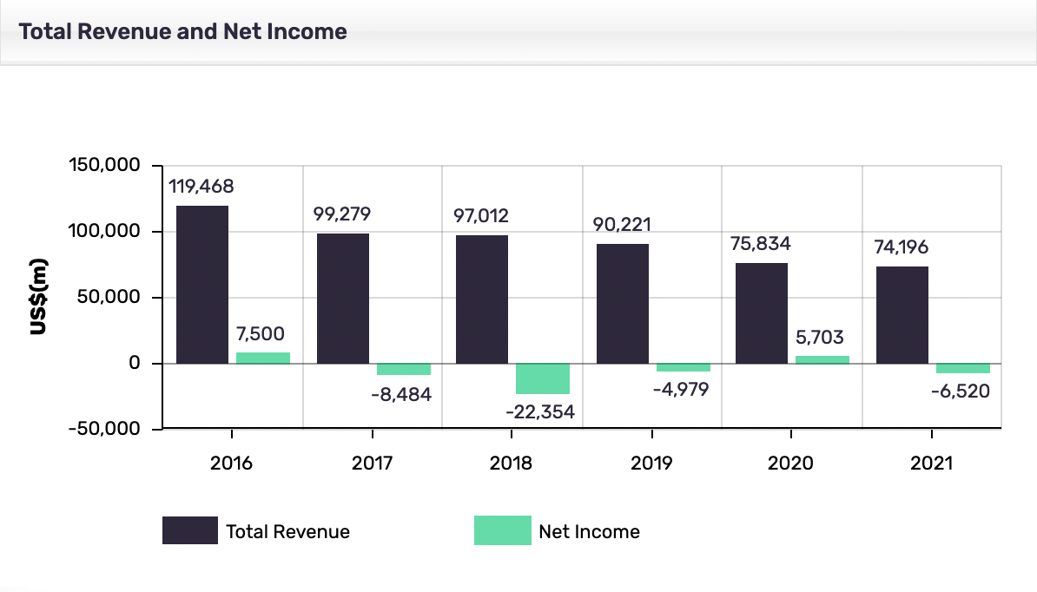

(MarketLine, 2022)

**Appendix B: General Electric Key Statistics**

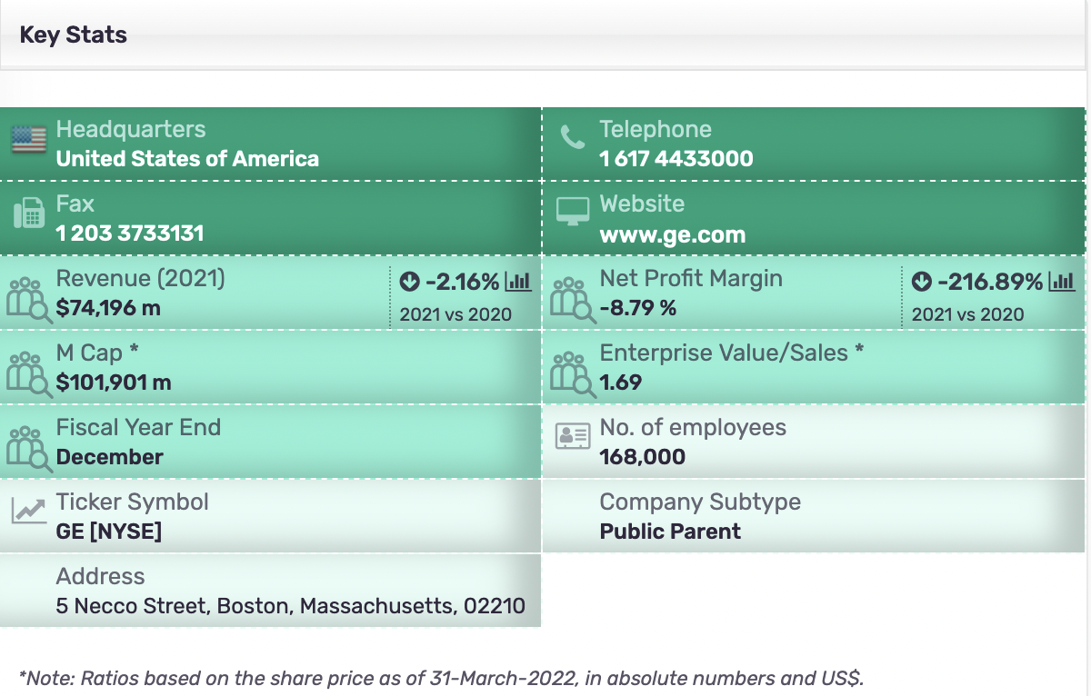

(MarketLine, 2022)

**Appendix C: General Electric SWOT Analysis**

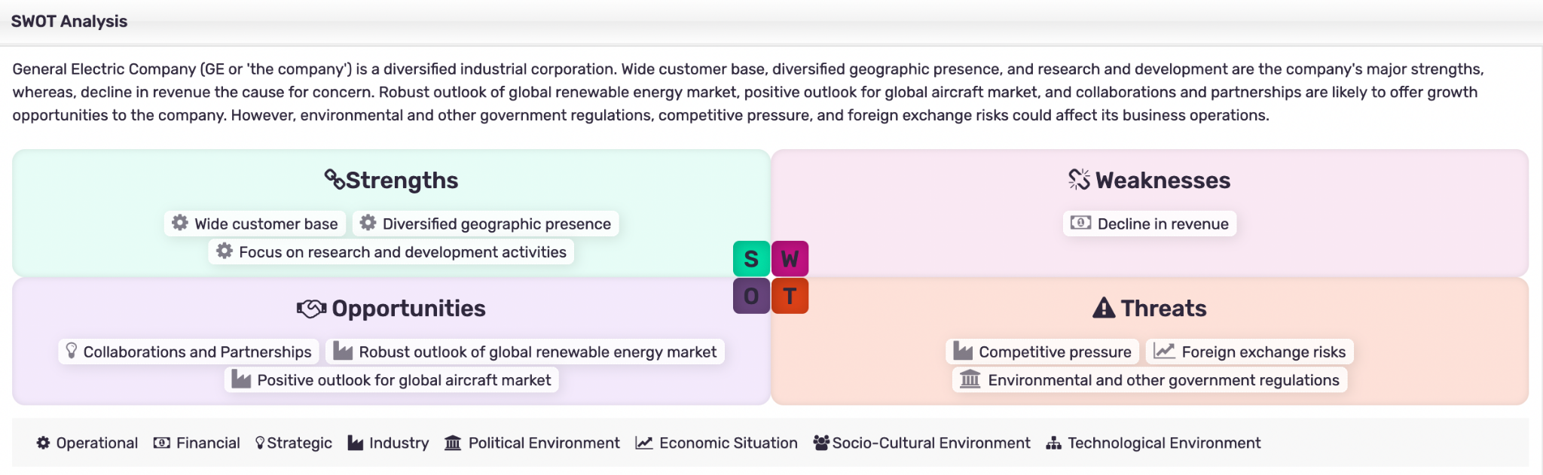

(MarketLine, 2022)

**Appendix D: General Electric Deals Overview**

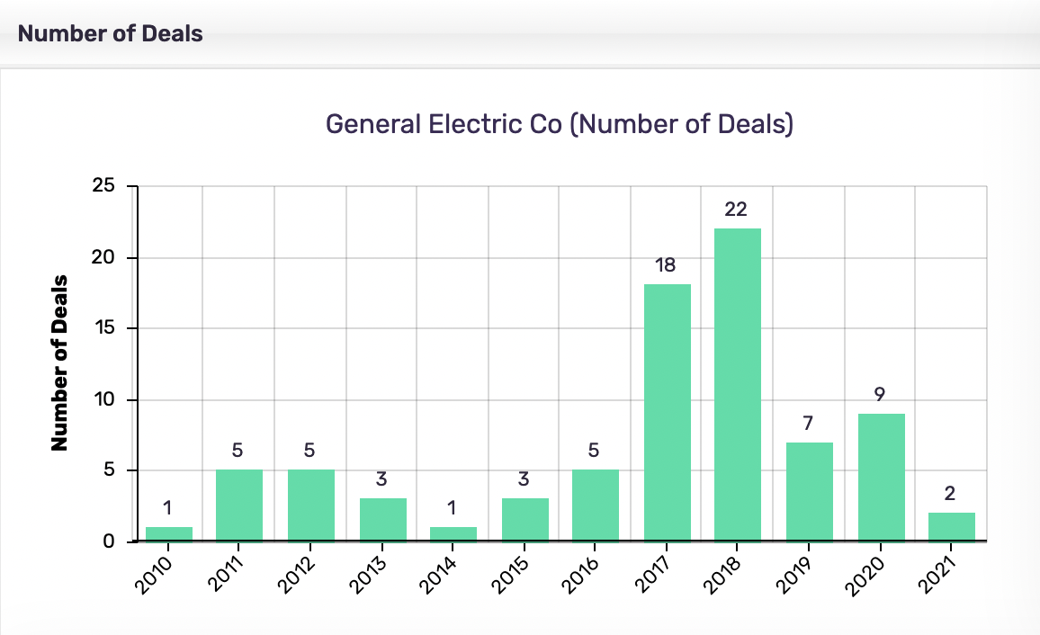

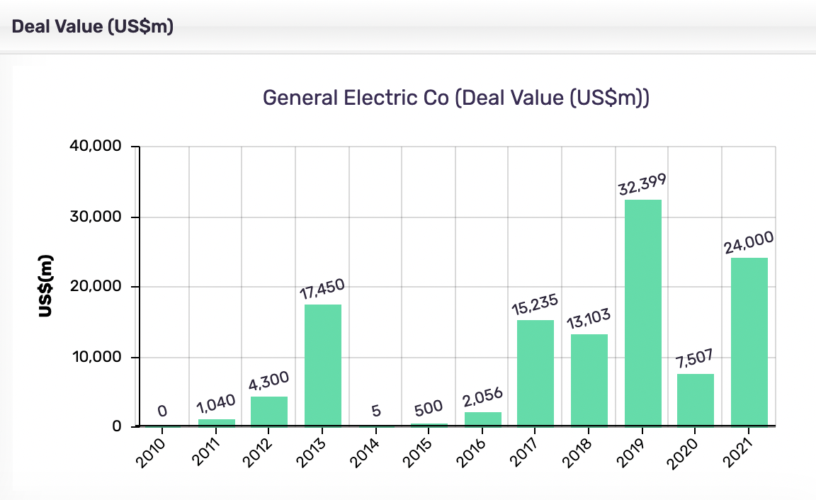

(MarketLine, 2022)