MKT 4310 International Export Marketing Plan
Student Name: Marlee Yerkes
Section #: 4310.002
Submitted to: Dr. Ruth Taylor
Date Submitted: November 22, 2021
Purpose of Submission: Extra Credit

International Export Marketing Plan

By Marlee Yerkes

Born and raised in Austin, Texas. I am a senior at Texas State University; I am getting my Bachelor of Business Administration in Management with a Concentration in Entrepreneurial Studies, and I plan to graduate May of 2022. In my free time, I wake surf on Lake Austin. I own and operate my own vegan and gluten free macaroon business seasonally, and I also help my dad with his business. I am very organized, love learning about changing business trends and real estate. I am enthusiastic to see what my career has in store in the future. I hope to start as many businesses as I can in my professional career.
There are many insights gained from this project. In my opinion, the most valuable insight was the use of multiple government and international websites. These websites provided knowledge and experience that are not typically found in a classroom setting. This project provided a chance for students to think about and solve real world issues with resources ranging from in class materials to international government websites. The uniqueness of this project allows the student to gain hands on experience with international marketing. It encourages the use of government website as resources to gain real world knowledge and information, then using this information to solve/complete the project. These resources can be used as tools to advance our careers in which ever industry we choose. There is an unlimited about of reliable, creditable, and relevant information in these resource that are now in our back pocket as we move up the latter in the business world.


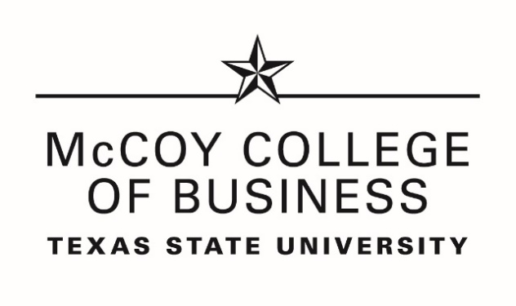


RESUME
Marlee Yerkes Austin, Texas – May48@txstate.edu

Summary
Born and raised in Austin, Texas. I am a senior at Texas State University; I am getting my Bachelor of Business Administration in Management with a Concentration in Entrepreneurial Studies, and I plan to graduate May of 2022. In my free time, I wake surf on Lake Austin. I own and operate my own vegan and gluten free macaroon business seasonally, and I also help my dad with his business. I am very organized, love learning about changing business trends and real estate. I am enthusiastic to see what my career has in store in the future. I hope to start as many businesses as I can in my professional career.

Education

Texas State University -Bachelor of Business Administration - BBA, In Management with a concentration in entrepreneurial studies | Aug 2019 – May 2022

Austin Community College - Bachelor of Science (BS), Hydrology and Water Resources Science | 2014 – 2019

University of Texas High School | 2014 – 2017

Special Training:

Government and International Websites Including: CIA Word Factbook, USA Trade, Bureau of Industry and Security, Office of the United States Trade Representative, The Coface, International Trade Administration, Freedom House, Transparency International, The Economist, Heritage Organization, Hofstede Insights, The World Bank, Omni Calculator.

Nautique Boat Operator - August 2008

Certification of Achievement - Dean’s List - Texas State University - May 2021

PADI Open Water Scuba Diver Certification – Cozumel Mexico Dive School – July 2021

TABC & Food Handlers License – August 2012

CPR Certification – August 2012

Service-Learning Certification – Texas State University - August 2021

Strategic Learning Certification – LinkedIn Learning – November 2021

Drill Team - Canyon Ridge - 2010

Experience

Business Founder - Marlee's Vegan Market | Nov 2017 – Present (4 yrs 1 mo)
- Salesperson - Jim's Smokehouse | Aug 2019 – Present (2 yrs 4 mos)
- Waitress - Guero's Taco Bar | Jan 2016 – Feb 2017 (1 yr 2 mos)
- Note Taker - Austin Community College | Jan 2016 – May 2016 (5 mos)
- Head Server - Lake Side Pizza and Grill | Aug 2012 – Jan 2016 (3 yrs 6 mos)

INTERNATIONAL EXPORT MARKETING PLAN
EXECUTIVE SUMMARY

1. Problem or need project was (did) to solve
There are many insights gained from this project. In my opinion, the most valuable insight was the use of multiple government and international websites. These websites provided knowledge and experience that are not typically found in a classroom setting. This project provided a chance for students to think about and solve real world issues with resources ranging from in class materials to international government websites. The uniqueness of this project allows the student to gain hands on experience with international marketing. It encourages the use of government website as resources to gain real world knowledge and information, then using this information to solve/complete the project. These resources can be used as tools to advance our careers in which ever industry we choose. There is an unlimited about of reliable, creditable, and relevant information in these resource that are now in our back pocket as we move up the latter in the business world.
2. Outline of Project’s (Plans) main goal (what is to be accomplished), objectives (how goal is to be accomplished) and expected outcomes (results expected from the process).
The main goal of the project in this class is establishing an export marking plan for a U.S. based company into an international region which the company does not currently resign. Our group chose The Honest Company as our company and Mexico as our country of export.
3. Explain the solution’s (completion of international Export Marketing Plan) actual outcome now that it is finished, and the value of the experience to you now and in the future.
Our group established an indirect export marketing plan in Mexico for The Honest Company. Diapers are The Honest Company’s most profitable products, so our group chose diaper to market in Mexico at tourist destinations. This involved numerous modules of research and planning to complete including a company analysis, analysis of social, cultural, political, legal, technological, ecological, and regulatory environments in Mexico, creating a target market segmentation for positioning, preparing a market entry strategy, assembling an export marking plan for the product, brand, packaging, pricing, and labeling, considering global channels and customer service in Mexico, analyzing communication and promotional elements. All these tasks were accomplished with the utilization of numerous government and international website. In the end, our team accomplished its goal of creating a indirect exporting marking plan for The Honest Company’s diapers in Mexico. The experience and information gained throughout the assignments will give us a unique advantage in our future career with skills learned through hands on activities in this course.
4. Wrap up your executive summary with a conclusion about the importance of the work.
This assignment developed students’ skills regarding researching of international markets and countries, problem solving, team communication, exporting market planning, analysis business environment and trends, trade and government restrictions country to country, and resume building. The principles learned will last throughout the future of our careers, encouraging our greatest potential.
INTERNATIONAL EXPORT MARKETING PLAN

TABLE OF CONTENTS

INTERNATIONAL EXPORT MARKETING PLAN: SECTION 1 - INTRODUCTION (Part 1 of 2) 6
INTERNATIONAL EXPORT MARKETING PLAN: SECTION 1: INTRODUCTION (Part 2/2) 8
INTERNATIONAL EXPORT MARKETING PLAN: SECTION 2 - CROSS-BORDER TARGET MARKET AND TARGET MARKET PROFILE 11
INTERNATIONAL EXPORT MARKETING PLAN: SECTION 3 – PLANNED CROSS-BORDER MARKETING MIX 13
INTERNATIONAL EXPORT MARKETING PLAN: SECTION 4 – APPENDICES 17
APPENDIX A: HS CODES 18
APPENDIX B: ABOUT MEXICO 19
APPENDIX C: INCOTERMS 22
APPENDIX D: THE HONEST COMPANY PHILOSOPHY 23
APPENDIX E: NAMES OF THE PEOPLE WHOM THIS PAPER WAS SHARED WITH 24

INTERNATIONAL EXPORT MARKETING PLAN: SECTION 1 - INTRODUCTION (Part 1 of 2)
Plan Development Team Members:
Marlee Yerkes Row 3 B1, Derrian Greene Row 4 B2, Valerie Cardenas Row 3 B3, Kevin Dao Row 4 B3
Date of International Export Marketing Plan Developed: Late August – Late November 2021
Country Team Studied and for which International Export Plan was Developed: Mexico
U.S. Company Team Studied: The Honest Company
Indicators of Team’s Company to launch to international market (team’s market) and ‘team’s Cross-Border Target Market Readiness/Acceptance for/of Product:
Team’s U.S. Company’s Readiness:
Ease of doing business score is 70. Family tourist destinations in Mexico are a great market for trending hypoallergenic products. Having been founded in 2012, this company is ready to continue expanding to other countries. Honest Beauty is prepared to expand their business to other areas, such as Mexico. They would be able to market and be able to handle expanding their facilities and locations in another country. Now that Honest Beauty is a recognized NASDAQ-GS company which increases the number of investments the company receives. Also, the Honest Company’s sales have increased 12% since 2020. As previously said, Honest management should be prepared for most things involved in exporting due to the exporting procedures they already have embarked on. One of the things would be needing to wait longer to receive payments and having adequate amounts of financial expenditures to finance production and marketing efforts. I have determined that Honest Beauty does possess organizational readiness due to already being able to export to other countries. This means that the company is prepared in terms of knowing how exporting should be organized and understanding the considerable amount of human and financial resources.
A couple of main factors that we believe will have an impact on our target market include gender, age, and income level. Because the Honest Company’s target market is mainly younger mothers, it automatically rules out male customers and narrows it down to women in their mid 20’s to their early 30’s. Income level will also impact the purchase of Honest products because people of lower income are less inclined to purchase their product while people of higher income are more likely to make a purchase. There generally would not be too many problems with acceptance since the Honest company boasts using all-natural material when manufacturing their diapers.
Some psychographics that we would need to consider are people that have children and care about the product they use on their child. Currently more women are having children at a younger age. Lastly, someone who cares about the environment because our products are all natural and that feature can attract environmentally cautious women.
Channels that we would like to use are people who follow models on social media and watch beauty videos that give them tips and tricks. People who watch product reviews are also a channel that we would use because that would allow us to possibly have a famous influencer to review our product on their platform. This would give us a chance to reach an audience that we would not normally reach if we only advertised on television or ads. Since a lot of people nowadays do not even watch television, this gives us a chance to reach those who may not be as connected.
Like mentioned before, we would most likely go into the route of picking our favorite influencers to review our product because people who aspire to be like their favorite influencers are more likely to purchase the stuff that they use. And for those who are not as socially connected, we would run television ads with famous celebrities like movie stars for example that people admire to possibly strengthen the appeal of our products.
Team’s Cross-Border Target Market Readiness:
A couple of main factors that we believe will have an impact on our target market include gender, age, and income level. Because the Honest Company’s target market is mainly younger mothers, it automatically rules out male customers and narrows it down to women in their mid 20’s to their early 30’s. Income level will also impact the purchase of Honest products because people of lower income are less inclined to purchase their product while people of higher income are more likely to make a purchase. There generally would not be too many problems with acceptance since the Honest company boasts using all-natural material when manufacturing their diapers.
Challenges we will face are not having a more diverse target market to reach different demographics like males for example. Since our target market is young mothers, we can also rule out the elderly since they are not advertising to them, and they are also very unlikely to buy our product as well. Also, since we have virtually no trade barriers in Mexico due to a trade agreement, we have with them and Canada, we can enter their country easily with little concerns about having to pay outrageous tariffs.
U.S. Company’s Product Team Chose to Export to and for which International Export Marketing Plan was Developed:
Indirect Export of The Honest Company’s Diapers in Mexico through distributors and agents.
Scope (planned reach) of Marketing Plan:
Our scope is at least five cities within Mexico including Mexico City, Cancun, Playa Del Carmen, Cozumel, and Cabo for our Marketing Plan to reach.
Environmental Factors Under Which Plan Was Developed and Under Which This Plan Will be Implemented:
The environmental factors studied prior to plan development followed the well-known, PESTLE Business Environmental Analysis framework, as follows:
Political: Current factors & identified trends having positive/negative effects on firm’s operations, and implications of them.
Economic: Current factors & identified trends having positive/negative effects on firm’s operations and implications of them.

Social/Cultural: Current factors & identified trends having positive/negative effect on firm’s operations and implications of them.

Technological: Current factors & identified trends having positive/negative effect on firm’s operations and implications of them.

Legal: Current factors & identified trends having positive/negative effects on firm’s
operations and implications of them.

Ecological; Current factors & identified trends having positive/negative effects on firm’s
operations and implications of them.

INTERNATIONAL EXPORT MARKETING PLAN: SECTION 1: INTRODUCTION (Part 2/2)

U.S. (Domestic country) Firm’s:
Mission re-Statement: The Honest Company’s mission statement is as follows, ‘Meaningful transparency and thoughtful design. We’re on a mission to change the world, one product at a time.’
Overall Attitude Toward International Expansion: Eager to expand to provide products with ‘Meaningful transparency and thoughtful design’ to more markets.
Overall goal (s) in International Expansion: Expansion is welcome in any feasible market where export is permitted as long as the company (manufacturing) can supply output.
Efforts toward being debtor or creditor to its firm’s environment’s bio-system: The Honest Company’s management toward being a creditor to its environment’s bio system is effectively communicated and showcased. They pride themselves in practicing safe environmental techniques such as with their packaging and how they emphasize the use of recycled materials. Also, they make compostable and biodegradable products.
Current Financial Condition: Our team’s current financial situation is that we are losing money every quarter.
Global Trade Patterns: The Honest Company focused on their exports to the and markets to the US, China, and Canada. They don’t typically import any ingredients or resources for their products, all products are made here in the U.S.
Brand Name & Slogan, if any, of product being exported to team’s country: For this moment. For every moment.’ is The Honest Company’s slogan.
Planned cross-border planned Entry Mode (Direct or Indirect): Indirect
Planned marketing distribution strategy (i.e., use of Distributors, and/or agents,
etc.) \ (identify them and the channel): We will use an indirect marketing approach, specifically the method will be with an Export Management Company in Mexico due to the familiar specialty with the products being sold in the foreign country. The business functions will remain normal under The Honest Company’s name while we simply just pay a commission for their services. Sales will continue to increase within this method due to the familiarity of the market with the control given to an Export Management Company.

U.S. (Domestic country) Firm’s Current Marketing Strategy:
Product Strategy:
Product features and benefits
These diapers are sustainable and eco-friendly designed naturally for baby comfort. They offer advanced leak protection which would help mothers and their babies keep everything in the diaper and not make messes. They also have stylish prints that help accessorize your baby and keep things fun. Honest diapers minimize diaper rash which helps the comfort for babies and mothers while also keeping the skin soft. Honest company refuses to add latex, fragrance, or parabens to this product for the comfort and safety of babies. Their diapers are also cruelty free, meaning they don’t test on animals which could benefit mothers who are against animal cruelty and testing. Some other features include:
- Belly button cutout (designed to stay out of the way of the baby’s healing umbilical cord)
- Quilted bubble liner (quickly draws wetness away for dryness of touch)
- Quick absorb channels (keeps leaks under wraps for quick dryness)
- Super stretchy sides (with flex + strength)
Product brand
Honest Baby Diapers is the brand name, and the tagline is “Stylish Diapers, Honest Comfort”.
Product packaging’
The Honest Diapers package is a white, rectangle about medium/large size that typically stores 32 diapers and is easy to store anywhere. The colors used are gray, brown, green, orange, pink, black, and white. Also uses pictures of babies
Package Labeling
- 32 diapers
- Caring caution: lists avoiding risk of choking and flammability of diapers, lists suffocation warning and to keep away from babies and children
- Materials: lists all the materials used in the product
- Location of design including state, location of production, contact information for Honest Company
- Distribution location (The Honest Company Inc. in Los Angeles, CA 90094)
- Size of product and diagram of how to use
- Gentle, durable
- Clean conscious diapers
- Absorbent/hypoallergenic/with plant-based materials
- 100% satisfaction guaranteed
- Our Honest Purpose, “To empower people, to live happy, healthy lives”
- Not tested on animal’s label, and to please recycle
- The print designs located in that specific package
- “Grow up with Honest”, size chart for babies and toddlers
- Famous and popular features of Honest Diapers

Place & Customer Service Strategies:

Segment 1 of International Distribution Strategy
The Honest Company will primarily distribute to supermarkets due to the vitalness of diapers to mothers and children, our target market. Most needs are purchased at supermarkets.
Segment 2 of International Distribution Strategy
Next location of distribution will be outdoor markets, research shows that the popularity of familiarity of outdoor markets in Mexico meets consumer demands and increases likelihood to purchase.
Segment 3 of International Distribution Strategy
Kiosks will also be a segment of our distribution strategy due to the possibility and likelihood that tourists along with citizens will purchase Honest products at these places.
Segment 4 of International Distribution Strategy
Shopping centers will be one of our distribution strategies so that mass populations will have access to products in an area that is known for purchase behavior and influence those to shop with The Honest Company.

Ideal distribution locations that are desired by Mexico are establishments such as kiosks, outdoor markets, covered places with shops, shopping centers and supermarkets.

Promotion Strategy:
The Honest Company will promote Honest Diapers through methods such as internet advertisement, TV advertisement, and radio advertisements to the Mexican population in the cities we choose to market in.
Honest Company will primarily focus on internet advertisement due to research showing that “85% of people buy at least one product or service on the internet in the last year” (santanertrade.com). Mexican consumers seem to be more open to international companies which will project success for the Honest Company and help with promotional efforts to the target market.
We will emphasize the natural and organic aspects of Honest products in our promotional strategies to our target market because the market for organic products in Mexico has grown 10% in the last year. The demand for organic products is rising, giving Honest Company a good head start in our promotional efforts. If we emphasize these features, sales are guaranteed to rise.

Price Strategy:

Our price strategy is structured upon the GDP per capita in Mexico being USD 20, 410 meaning it’s lower than the US. We must plan a price sensitive and sensible strategy to appeal to consumers in Mexico, reassuring that they will be affordable yet also make somewhat of a profit. Consumption has decreased in the past year so we must keep this in mind as we design prices for our products to have successful business in this location. Also, to reach out target market, women, we must keep in mind that research shows that the women in the labor force is in the lowest tier in the OECD countries, therefore prices will be low-medium to medium- high ensuring that most or hopefully all mothers will be able to afford Honest Diapers.

Current Average Annual Sales of Team’s Product: U.S. sales $49,574,000; International Sales $37,402,000.

INTERNATIONAL EXPORT MARKETING PLAN: SECTION 2 -
CROSS-BORDER TARGET MARKET AND TARGET MARKET PROFILE
Country of Market Entry: Mexico

Cross-border Target Market Profile:
A couple of main factors that we believe will have an impact on our target market include gender, age, and income level. Because the Honest Company’s target market is mainly younger mothers, it automatically rules out male customers and narrows it down to women in their mid 20’s to their early 30’s. Income level will also impact the purchase of Honest products because people of lower income are less inclined to purchase their product while people of higher income are more likely to make a purchase. There generally would not be too many problems with acceptance since the Honest company boasts using all-natural material when manufacturing their diapers.
Some psychographics that we would need to consider are people that have children and care about the product they use on their child. Currently more women are having children at a younger age. Also, people who care about the physical appearance of their skin. These people can also be people who are heavily on social media, maybe they look up to a certain model they aspire to look like, or simply just following a trend online. Furthermore, someone who values how they always look. Someone who works all day outside in construction is probably not as likely to purchase skin care products rather than someone whose job or occupation is indoors or less strenuous. Lastly, someone who cares about the environment because our products are all natural and that feature can attract environmentally cautious women.
Challenges we will face are not having a more diverse target market to reach different demographics like males for example. Since our target market is young mothers, we can also rule out the elderly since they are not advertising to them, and they are also very unlikely to buy our product as well. Also, since we have virtually no trade barriers in Mexico due to a trade agreement, we have with them and Canada, we can enter their country easily with little concerns about having to pay outrageous tariffs.
Channels that we would like to use are people who follow models on social media and watch beauty videos that give them tips and tricks. People who watch product reviews are also a channel that we would use because that would allow us to possibly have a famous influencer to review our product on their platform. This would give us a chance to reach an audience that we would not normally reach if we only advertised on television or ads. Since a lot of people nowadays do not even watch television, this gives us a chance to reach those who may not be as connected.
Like mentioned before, we would most likely go into the route of picking our favorite influencers to review our product because people who aspire to be like their favorite influencers are more likely to purchase the stuff that they use. And for those who are not as socially connected, we would run television ads with famous celebrities like movie stars for example that people admire to possibly strengthen the appeal of our products.

Mode or Method of Market Entry (Direct or Indirect): Indirect

Product’s HS Code: 33.04 and 3304.91

Resource Utilized:

U.S. Government Level:

CIA Word Factbook, USA Trade, Bureau of Industry and Security, Office of the United States Trade Representative.

U.S. World Level:

The Coface, International Trade Administration, Freedom House, Transparency International, The Economist, Heritage Organization, Hofstede Insights, The World Bank.

Others: Omni Calculator.

INTERNATIONAL EXPORT MARKETING PLAN: SECTION 3 –
PLANNED CROSS-BORDER MARKETING MIX
Section 3.A:
International Product Strategy:
These diapers are sustainable and eco-friendly designed naturally for baby comfort. They offer advanced leak protection which would help mothers and their babies keep everything in the diaper and not make messes. They also have stylish prints that help accessorize your baby and keep things fun. Honest diapers minimize diaper rash which helps the comfort for babies and mothers while also keeping the skin soft. Honest company refuses to add latex, fragrance, or parabens to this product for the comfort and safety of babies. Their diapers are also cruelty free, meaning they don’t test on animals which could benefit mothers who are against animal cruelty and testing. Some other features include:
- Belly button cutout (designed to stay out of the way of the baby’s healing umbilical cord)
- Quilted bubble liner (quickly draws wetness away for dryness of touch)
- Quick absorb channels (keeps leaks under wraps for quick dryness)
- Super stretchy sides (with flex + strength)
International Branding Strategy:
Honest Baby Diapers is the brand name, and the tagline is “Stylish Diapers, Honest Comfort”.
International Packaging Strategy:
The Honest Diapers package is a white, rectangle about medium/large size that typically stores 32 diapers and is easy to store anywhere. The colors used are gray, brown, green, orange, pink, black, and white. Also uses pictures of babies
International Labeling Strategy:
- 32 diapers
- Caring caution: lists avoiding risk of choking and flammability of diapers, lists suffocation warning and to keep away from babies and children
- Materials: lists all the materials used in the product
- Location of design including state, location of production, contact information for Honest Company
- Distribution location (The Honest Company Inc. in Los Angeles, CA 90094)
- Size of product and diagram of how to use
- Gentle, durable
- Clean conscious diapers
- Absorbent/hypoallergenic/with plant-based materials
- 100% satisfaction guaranteed
- Our Honest Purpose, “To empower people, to live happy, healthy lives”
- Not tested on animal’s label, and to please recycle
- The print designs located in that specific package
- “Grow up with Honest”, size chart for babies and toddlers
- Famous and popular features of Honest Diapers
Section 3.B:
International Place Strategy & Customer Service Strategy:
Segment 1 of International Distribution Strategy
The Honest Company will primarily distribute to supermarkets due to the vitalness of diapers to mothers and children, our target market. Most needs are purchased at supermarkets.
Segment 2 of International Distribution Strategy
Next location of distribution will be outdoor markets, research shows that the popularity of familiarity of outdoor markets in Mexico meets consumer demands and increases likelihood to purchase.
Segment 3 of International Distribution Strategy
Kiosks will also be a segment of our distribution strategy due to the possibility and likelihood that tourists along with citizens will purchase Honest products at these places.
Segment 4 of International Distribution Strategy
Shopping centers will be one of our distribution strategies so that mass populations will have access to products in an area that is known for purchase behavior and influence those to shop with The Honest Company.
Ideal distribution locations that are desired by Mexico are establishments such as kiosks, outdoor markets, covered places with shops, shopping centers and supermarkets.
Customer services that are desired by young mothers in Mexico are organic, time saving, and reliable products that are easily available to purchase for fair prices that are affordable. Overall customer service is important to Mexican consumers thus the areas of distribution we chose are heavily influenced locations that rely on good customer service. Mexican consumers are also one of the most brand loyal customers in the world, thus it is vital that Honest Company makes a great first impression with each consumer to build a great brand relationship.
Organic and time saving customer services need to be provided from the Honest Company, because our target market focuses on these attributes the most and wish to purchase products from companies that provide these services. Mothers want these customer services to make their and their children’s lives easier knowing that they purchase products that promote productivity and are safe for their babies.
Reliability is an important customer service The Honest Company must provide to our target market because our products are directed to their babies. They want to be able to trust the company they purchase from and expect high results.
Section 3.C:
International Promotion/Integrated Marketing Communication (IMC) Strategy:
The Honest Company will promote Honest Diapers through methods such as internet advertisement, TV advertisement, and radio advertisements to the Mexican population in the cities we choose to market in.
Honest Company will primarily focus on internet advertisement due to research showing that “85% of people buy at least one product or service on the internet in the last year” (santanertrade.com). Mexican consumers seem to be more open to international companies which will project success for the Honest Company and help with promotional efforts to the target market.
We will emphasize the natural and organic aspects of Honest products in our promotional strategies to our target market because the market for organic products in Mexico has grown 10% in the last year. The demand for organic products is rising, giving Honest Company a good head start in our promotional efforts. If we emphasize these features, sales are guaranteed to rise.
Section 3.D:
Price Strategy:
Our price strategy is structured upon the GDP per capita in Mexico being USD 20, 410 meaning it’s lower than the US. We must plan a price sensitive and sensible strategy to appeal to consumers in Mexico, reassuring that they will be affordable yet also make somewhat of a profit. Consumption has decreased in the past year so we must keep this in mind as we design prices for our products to have successful business in this location. Also, to reach out target market, women, we must keep in mind that research shows that the women in the labor force is in the lowest tier in the OECD countries, therefore prices will be low-medium to medium- high ensuring that most or hopefully all mothers will be able to afford Honest Diapers.

INTERNATIONAL EXPORT MARKETING PLAN: SECTION 4 – APPENDIces

APPENDIX A: HS CODES

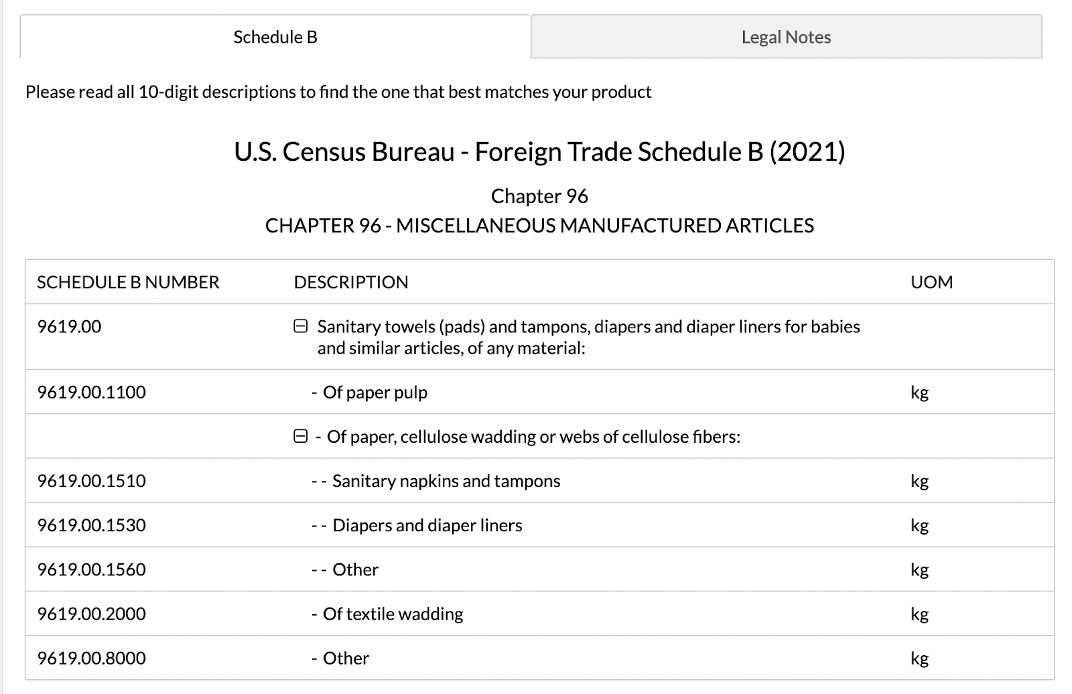

Source: More on Diaper HS Codes:
https://www.flexport.com/data/hs-code/961900-sanitary-towels-and-tampons-diapers-for-babies-

APPENDIX B: ABOUT MEXICO

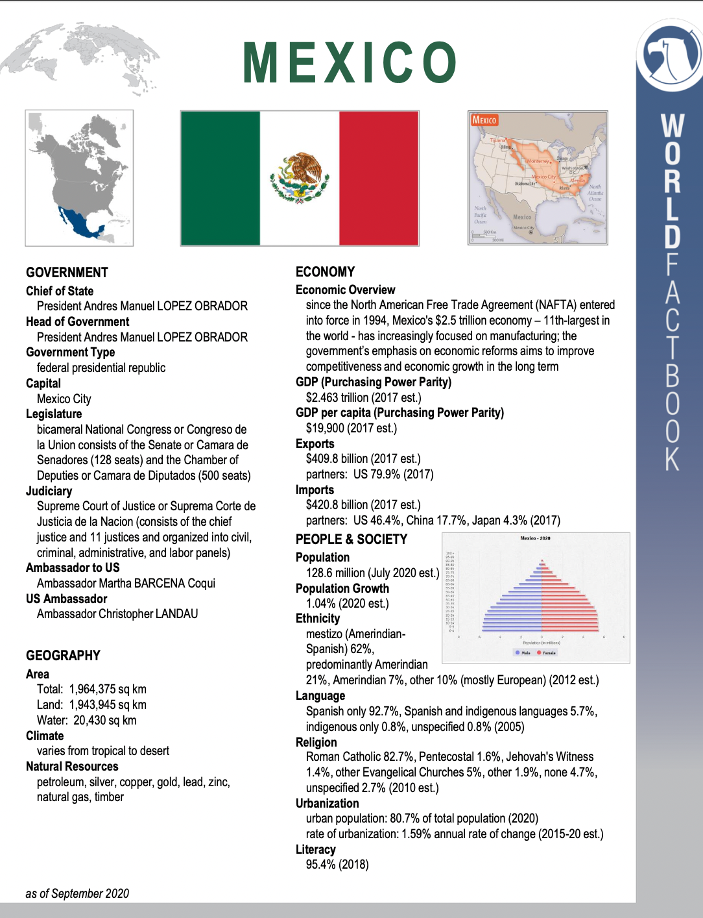
Source:
https://www.cia.gov/the-world-factbook/countries/

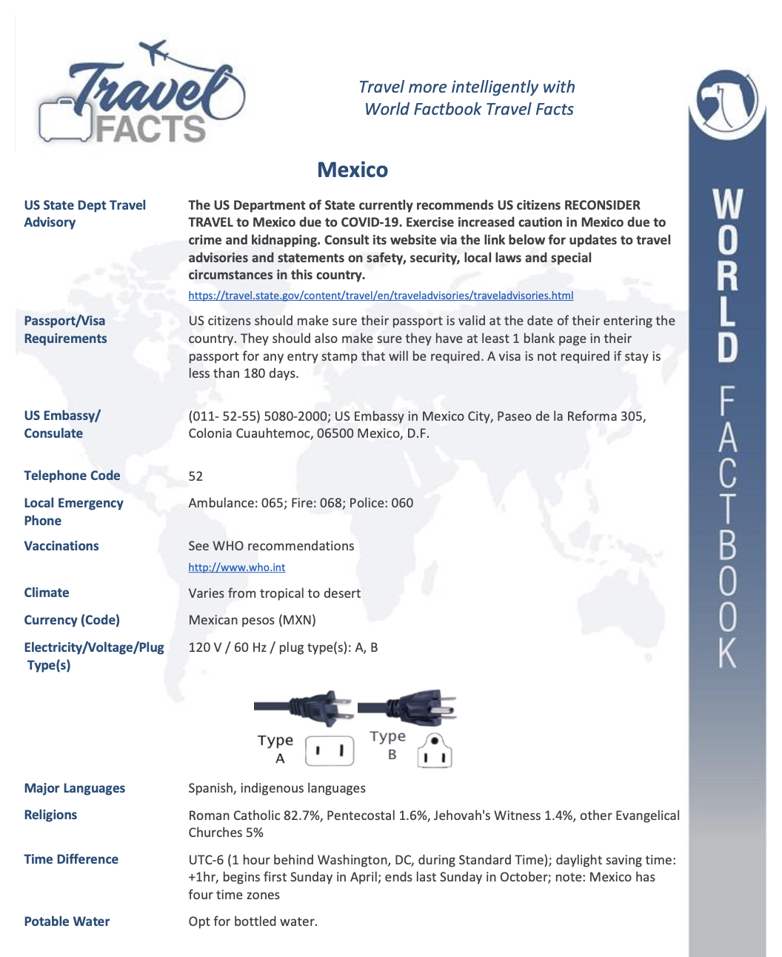
Source:
https://www.cia.gov/the-world-factbook/countries/

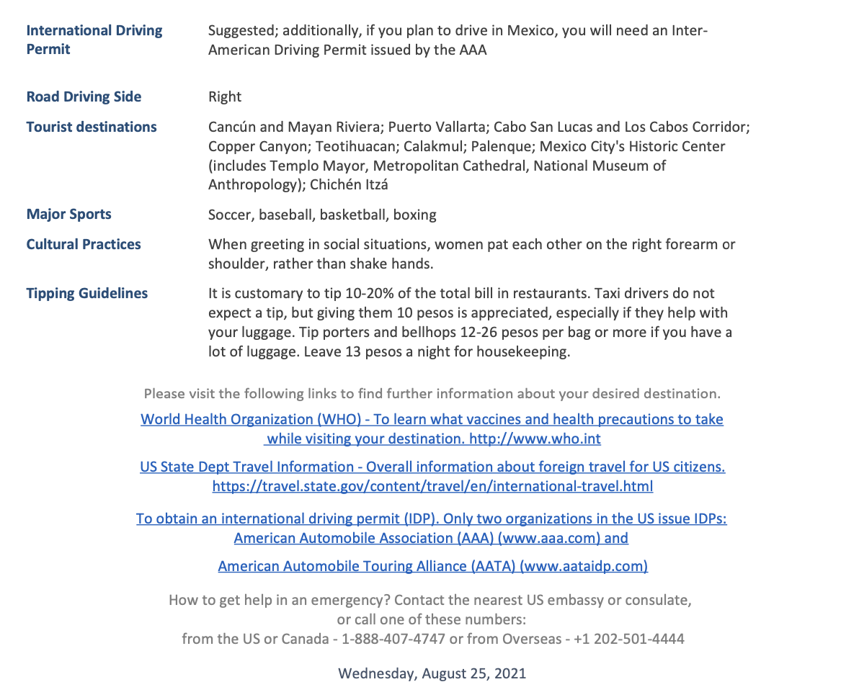
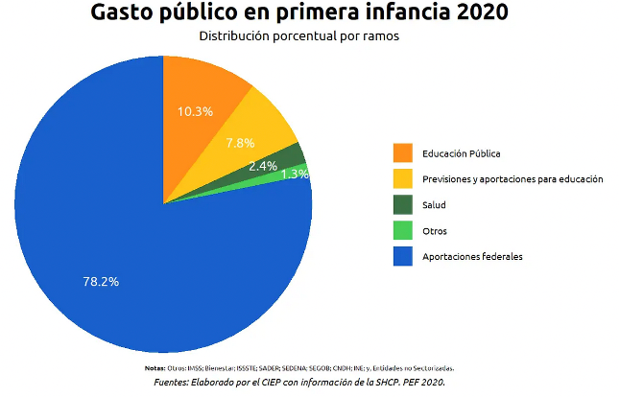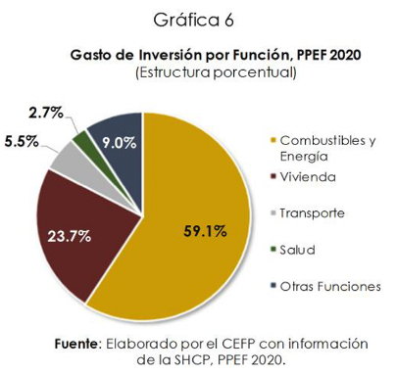

Source:
https://www.cia.gov/the-world-factbook/countries/

APPENDIX C: INCOTERMS

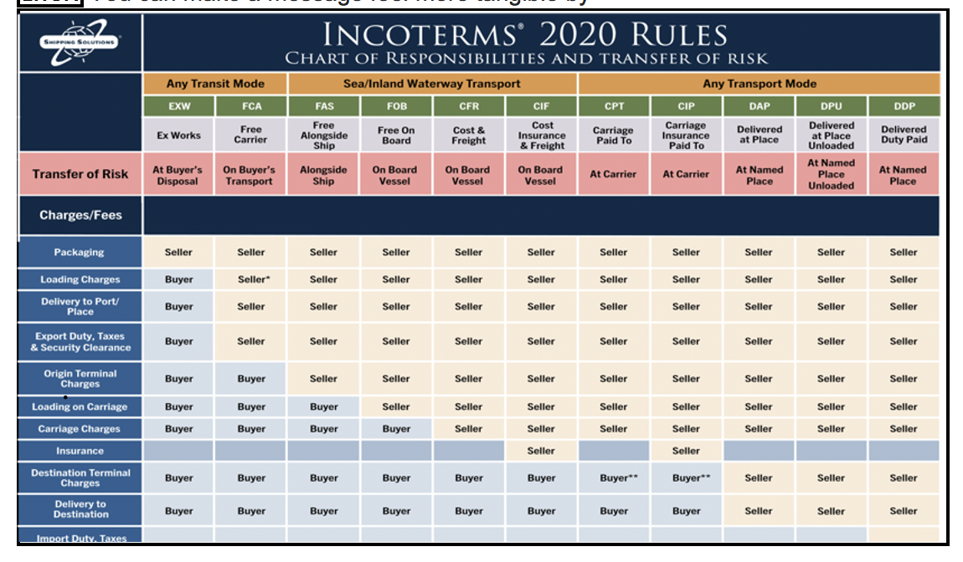
Source:
http://export.gov/about/eg_main_016806.asp

APPENDIX D: THE HONEST COMPANY PHILOSOPHY

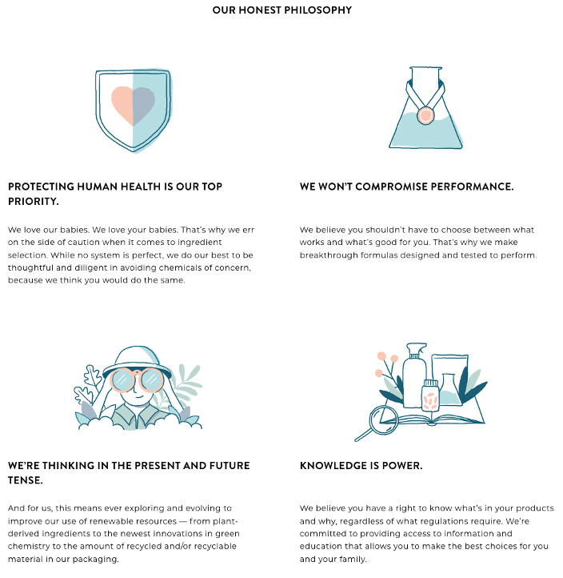
Source:
https://www.honest.com/?gclid=Cj0KCQiAkNiMBhCxARIsAIDDKNVcmSus2_ORuxZGyRvFt1NCAJj-pXhscMneys9cl6dJDeJfUFDqX50aAg_vEALw_wcB

APPENDIX E: NAMES OF THE PEOPLE WHOM THIS PAPER WAS SHARED WITH

Amber Howell
Amber.howell155@gmail.com
Amber thought the assignment was great and could not believe how many topics we covered. She loved all my charts in the appendices and was fascinated with the overall plan.
Kennedy Hell
Kennedyhell01@gmail.com
Kennedy was also astonished with the length and detail of the project. She loved learning about the honest company and is actually now considering using their products.
Sophie Temple
Sophie.temple288@gmail.com
Sophie was interesting in all the government websites used in the project. We got online and I showed her some of them and how to navigate the page. She loved learning about Mexico and all its differences compared to other countries.
Dolores Palmisano
Dolores.palmisano@yahoo.com
Dolores loved my resume and special training. She gave me pointer to improve my resume, but she also loved the overall project. She told me I should take it to The Honest Company and try to get a paid partnership. We also enjoyed talking about all the graphs.
Austin Yerkes
austinyerkes@yahoo.com
Austin was amazed with the detail and length of the assignment. He could not believe we had put so much work into one project in one semester. We loved the idea of targeting tourist hot spot in Mexico and enjoyed learning about the culture.
VyVy Tran
Vyvytran5106@gmail.com
Vyvy thought my project was very organized and well written. She loved hearing about the honest company and their mission. She had lots of questions about their values and the products they offer and why we choose the honest company. It was fun to share with her all that I learned in this course.

